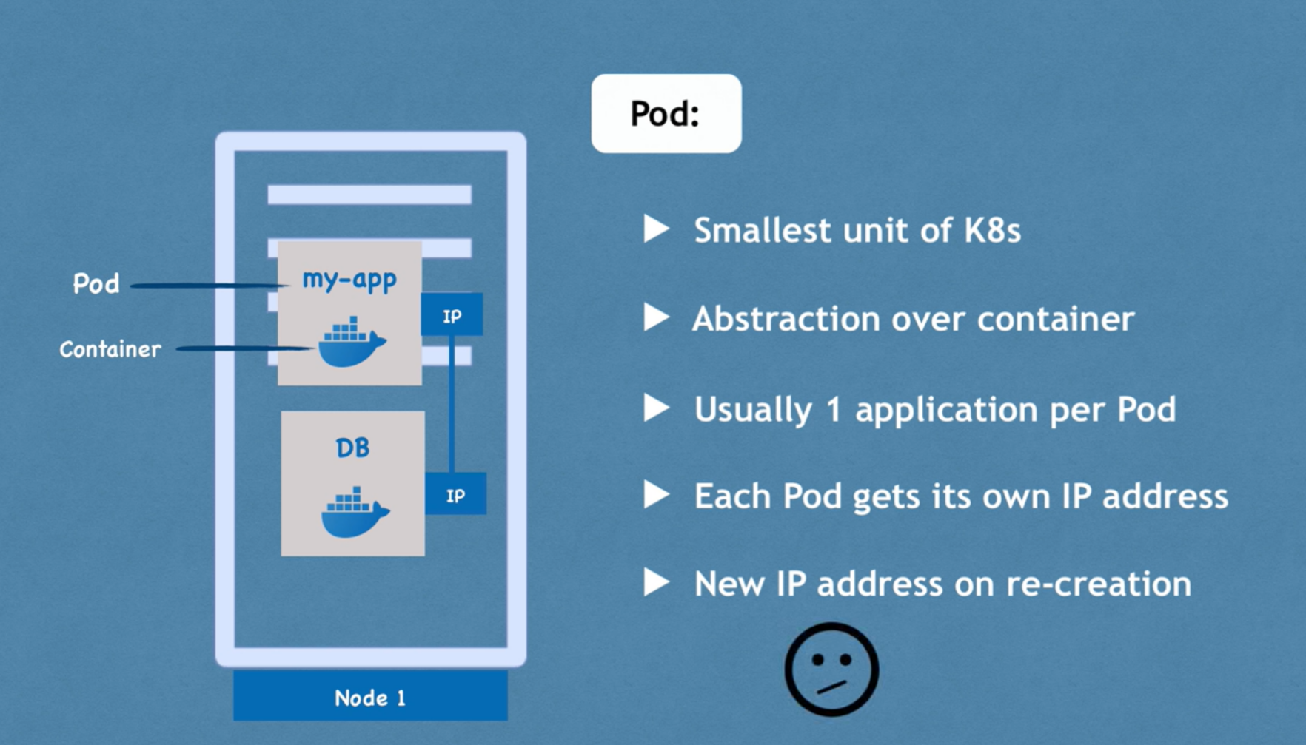 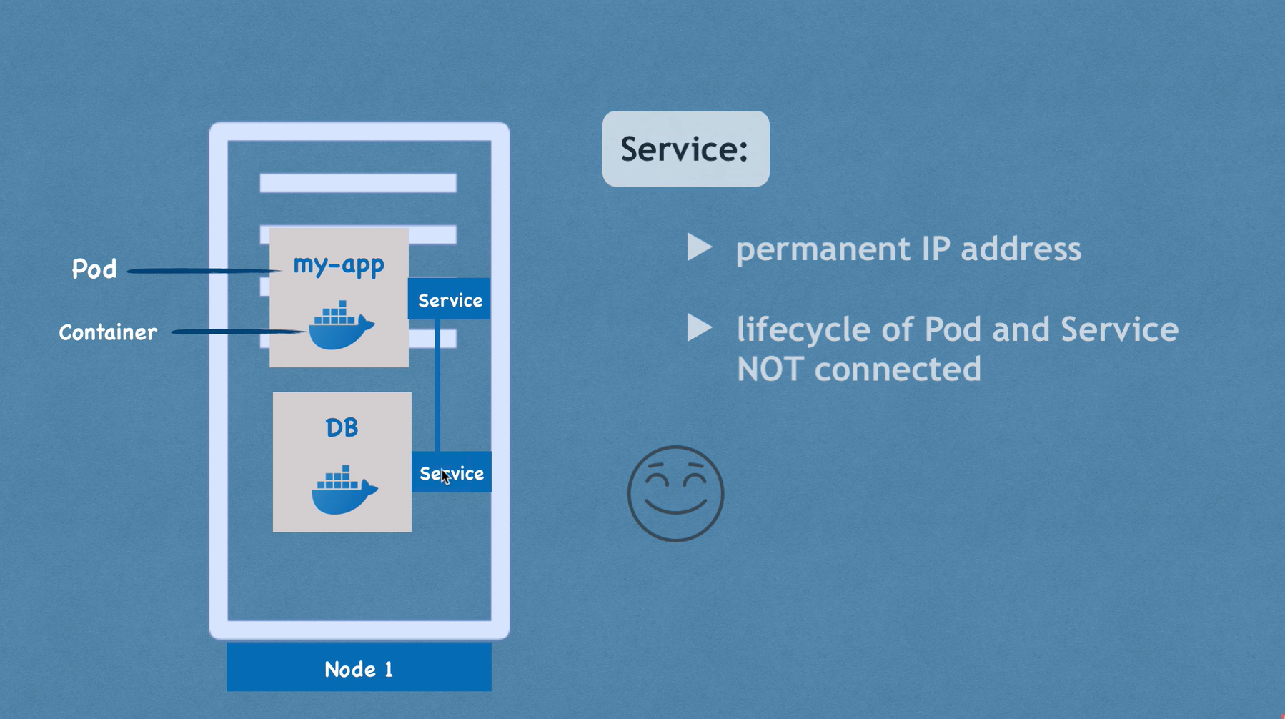 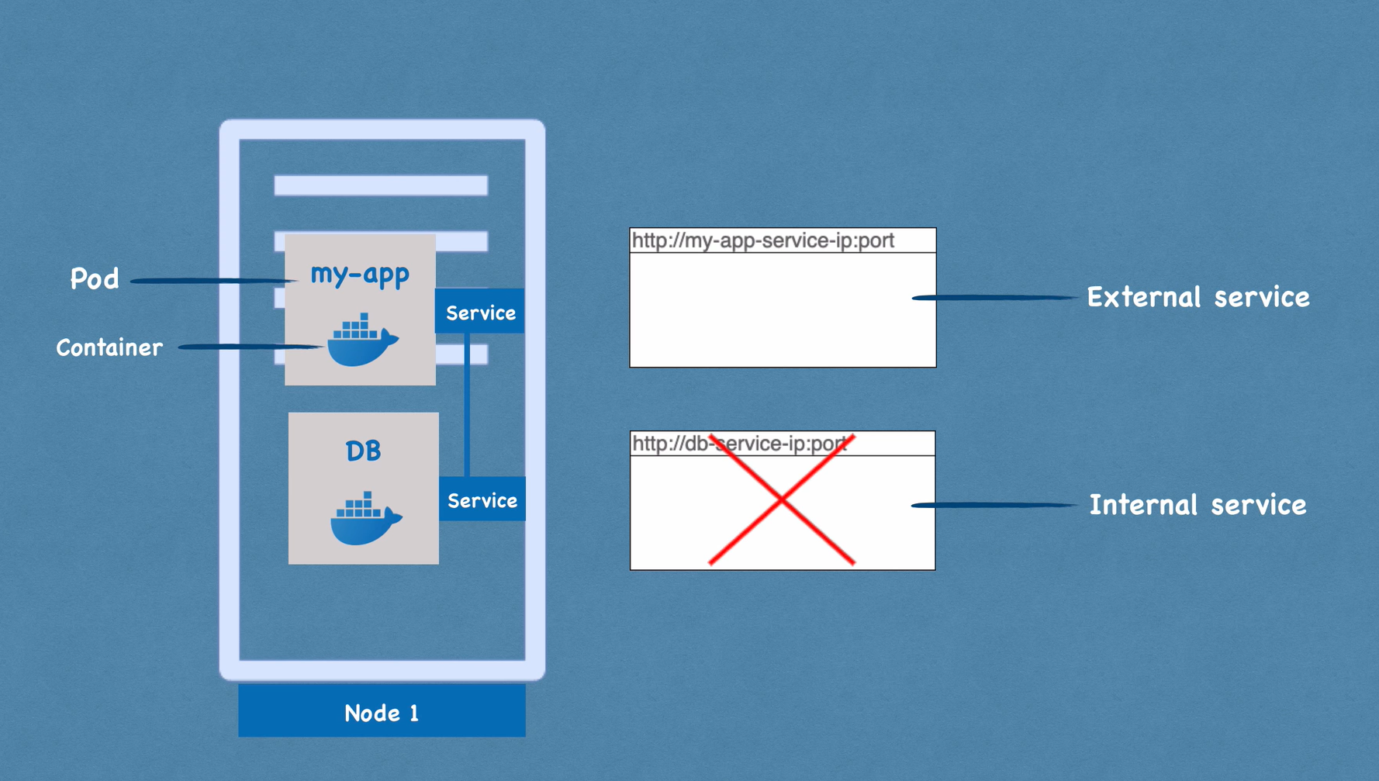 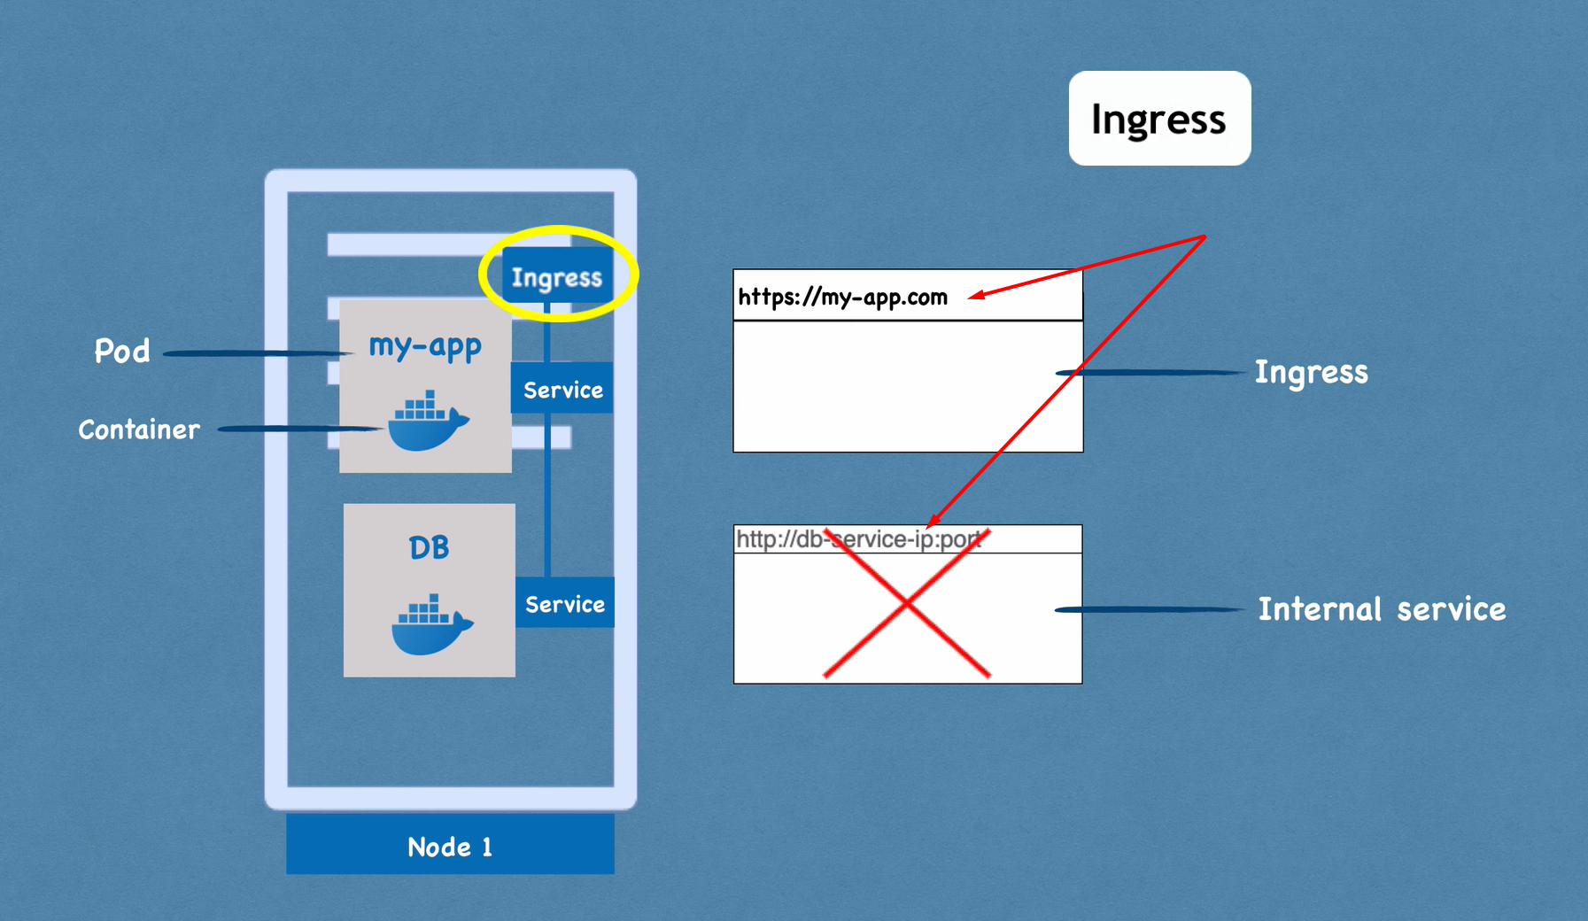 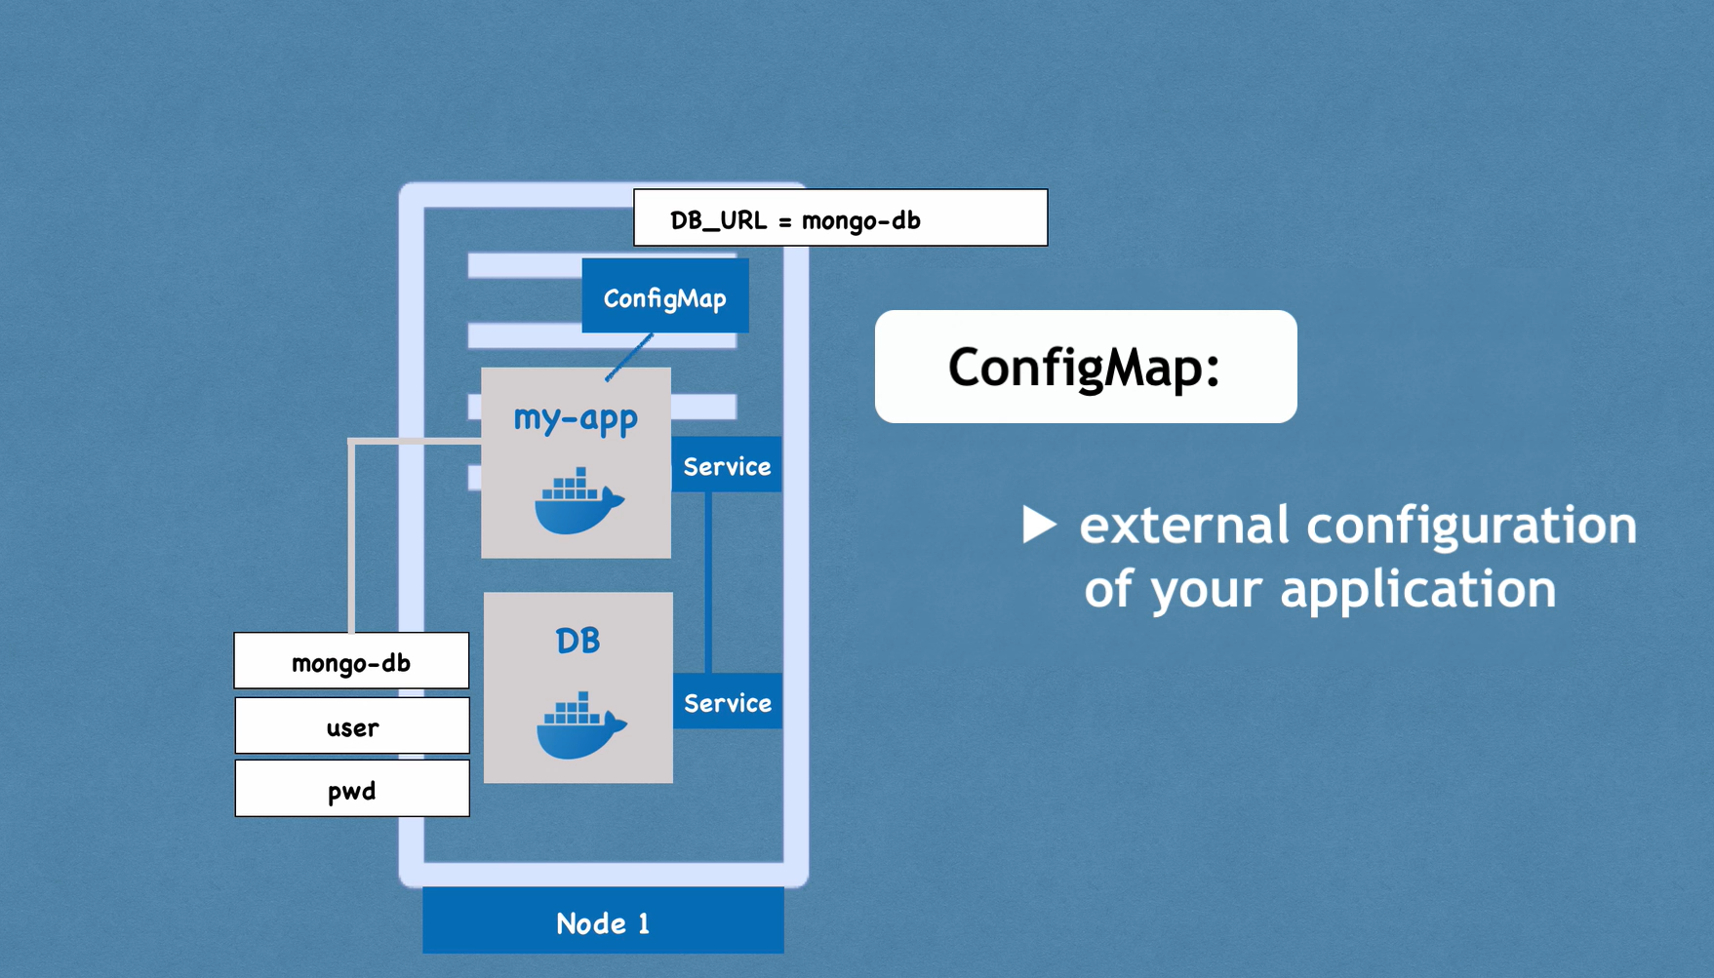 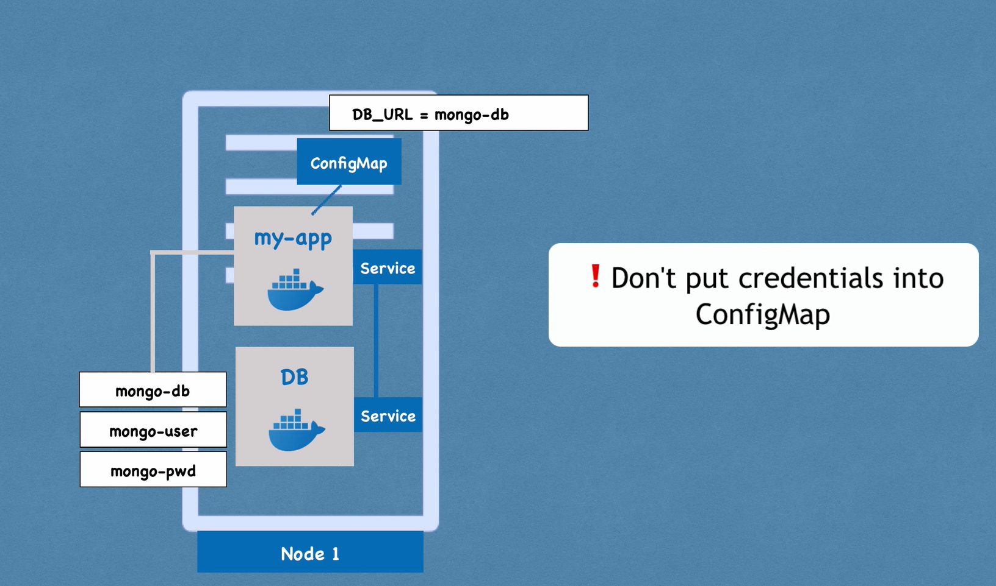 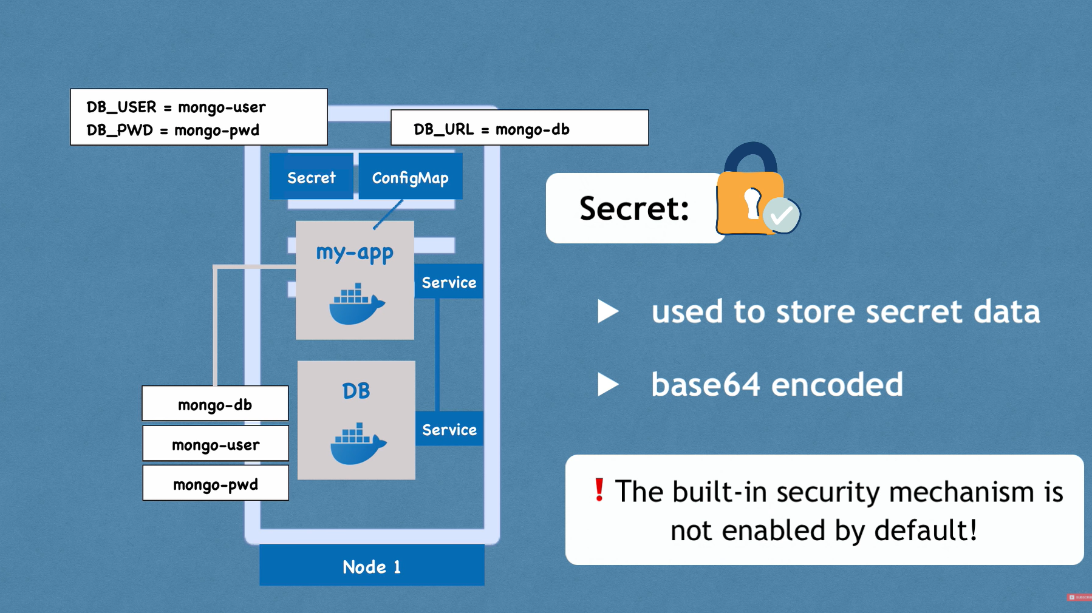 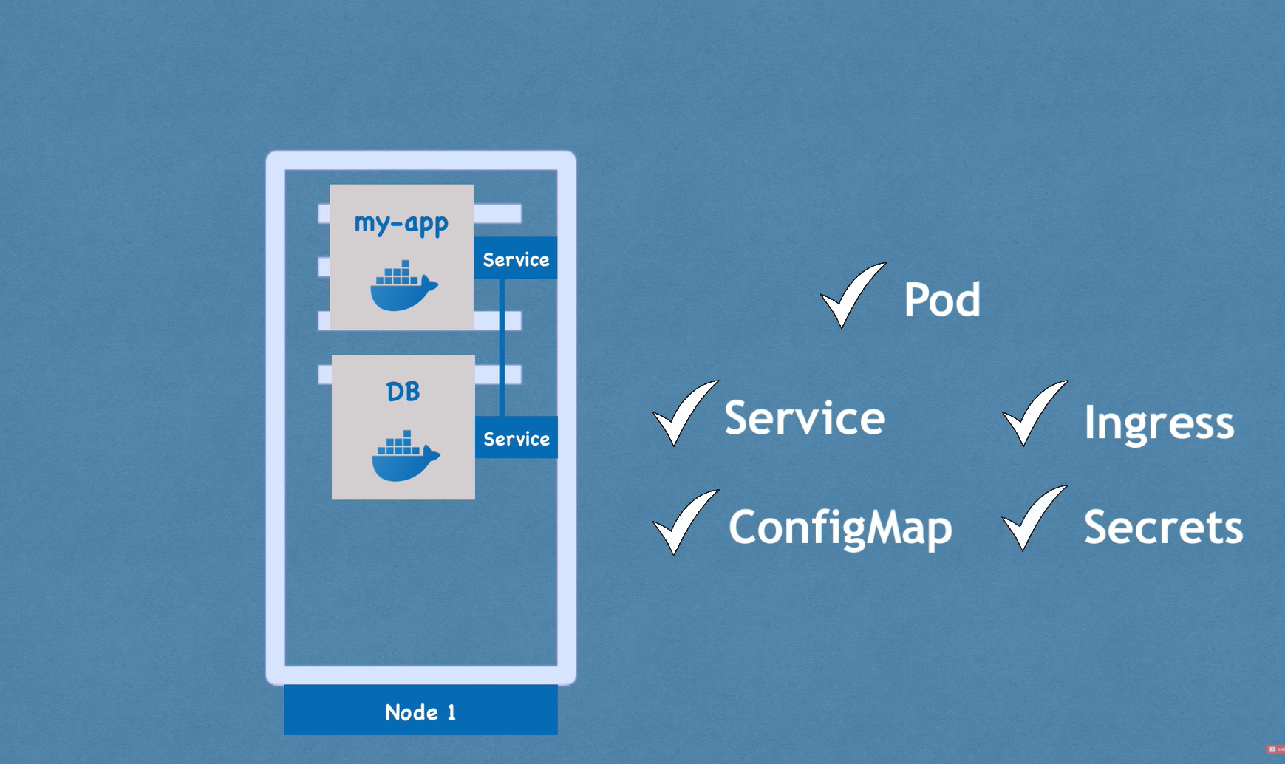 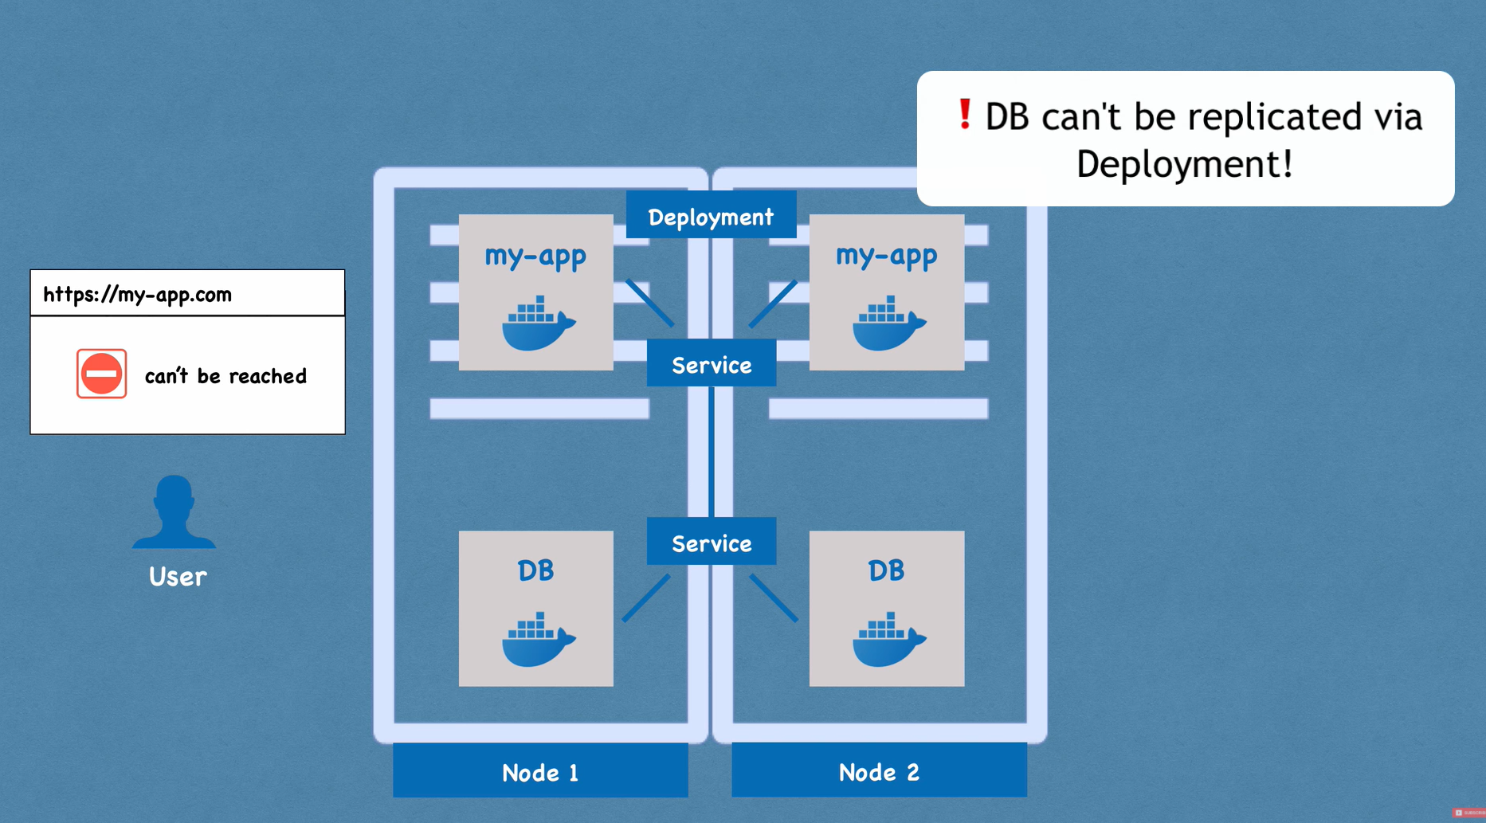 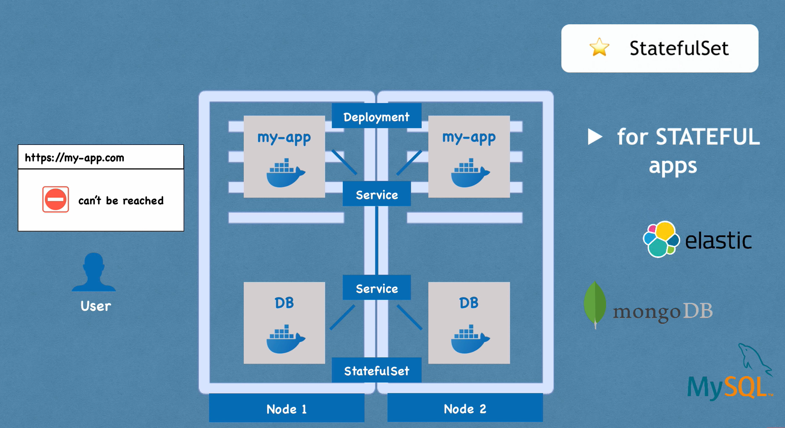 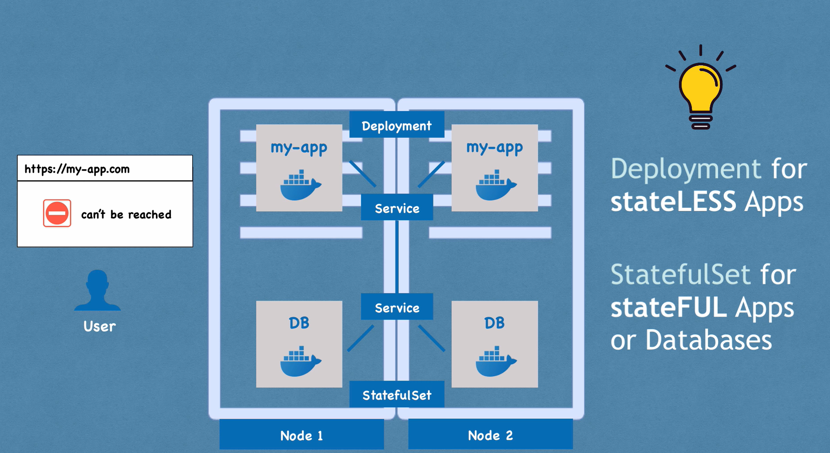 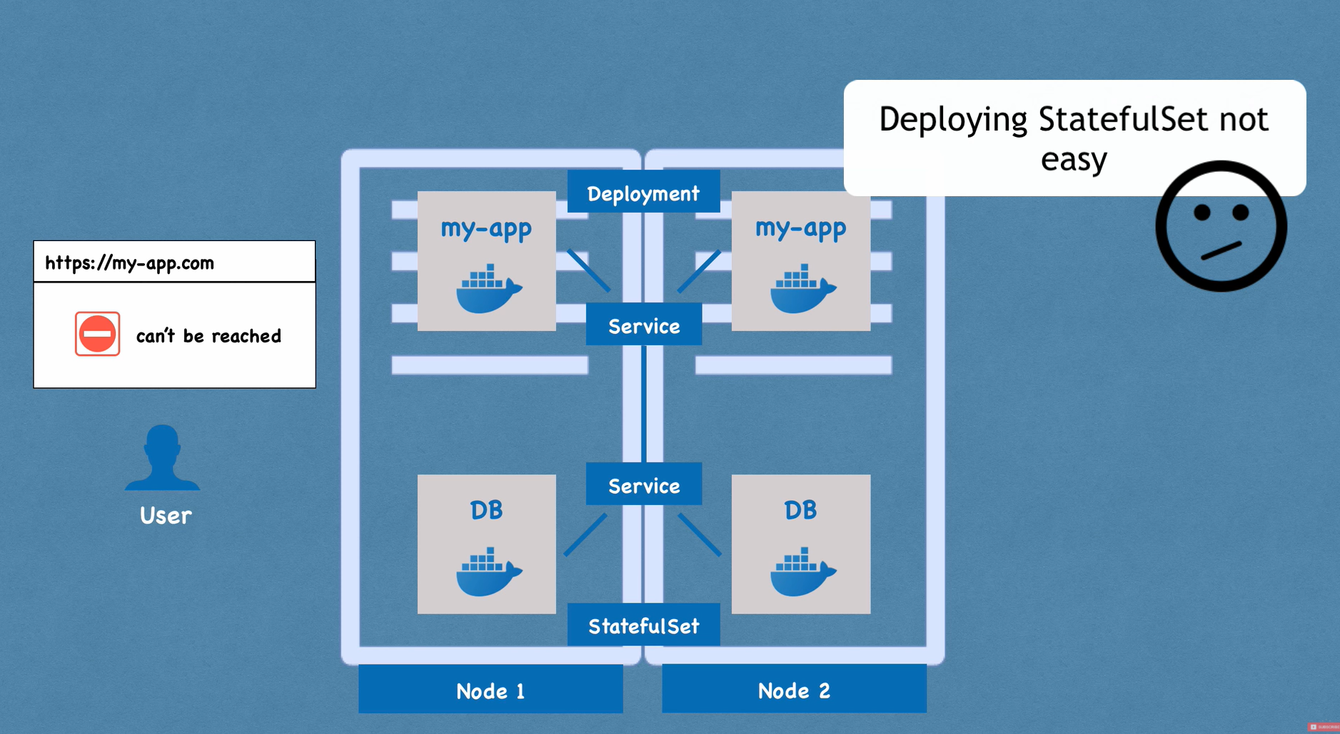 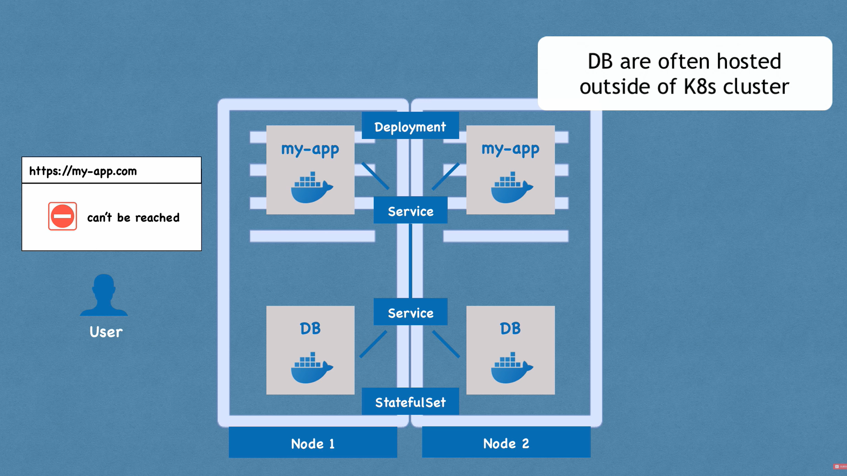 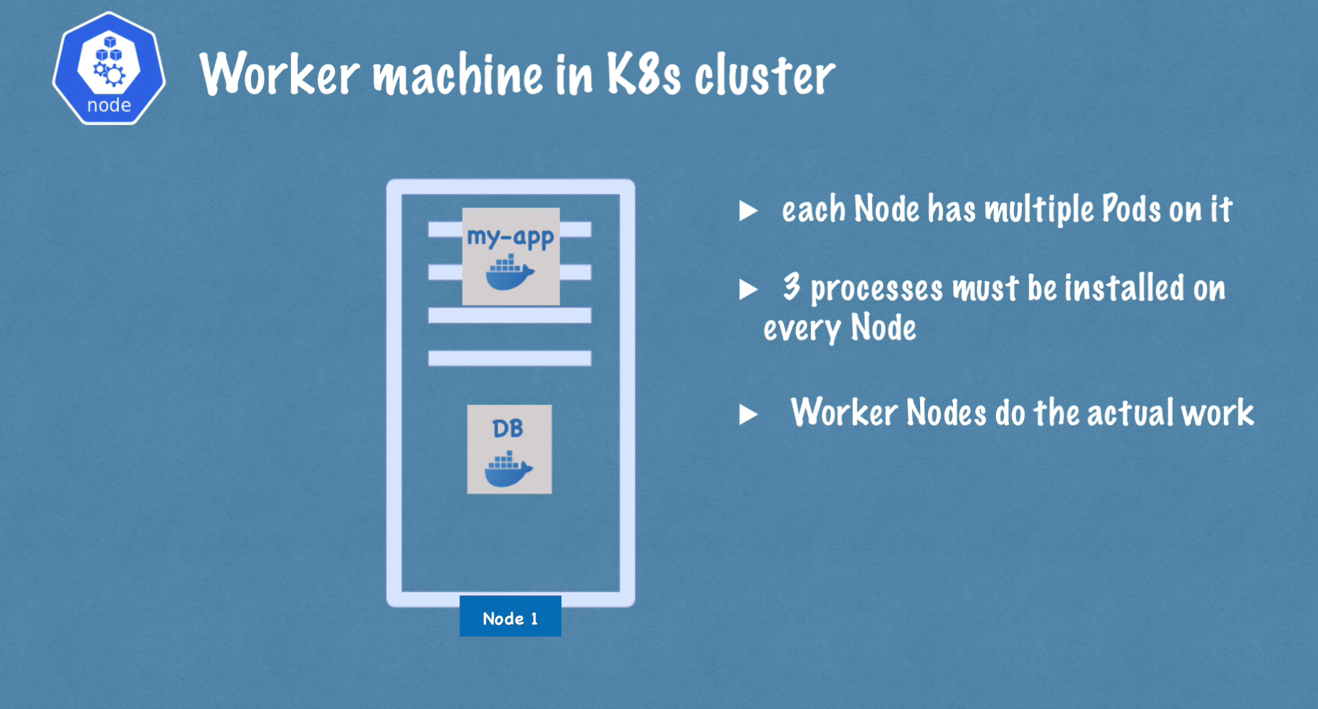 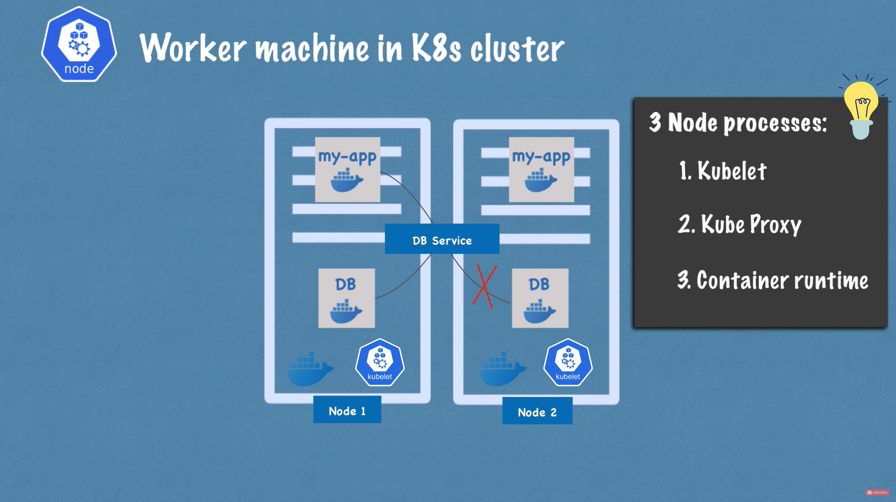 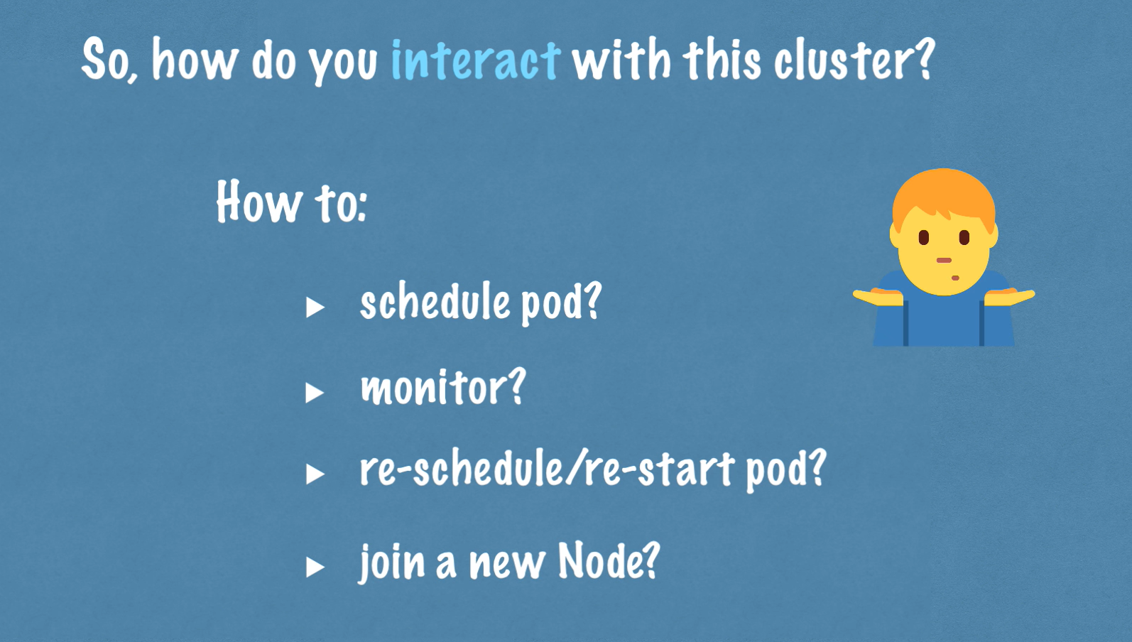 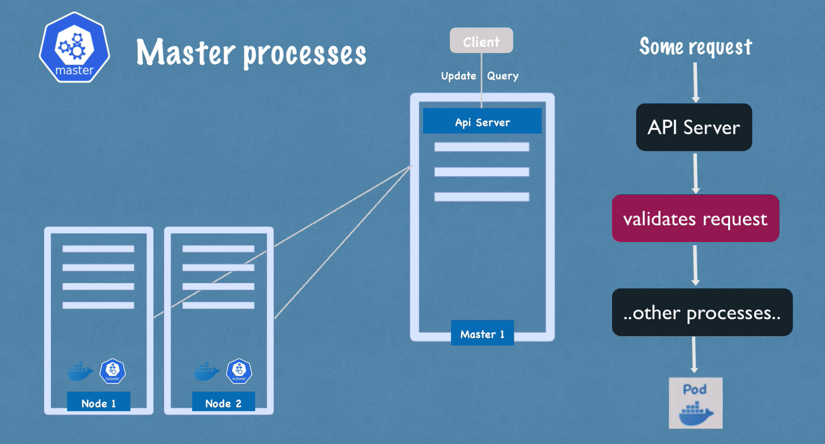 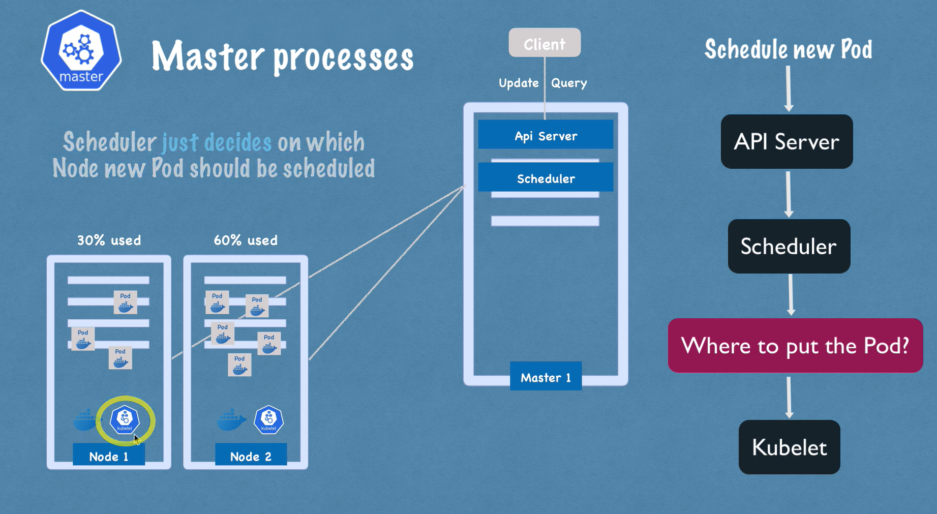 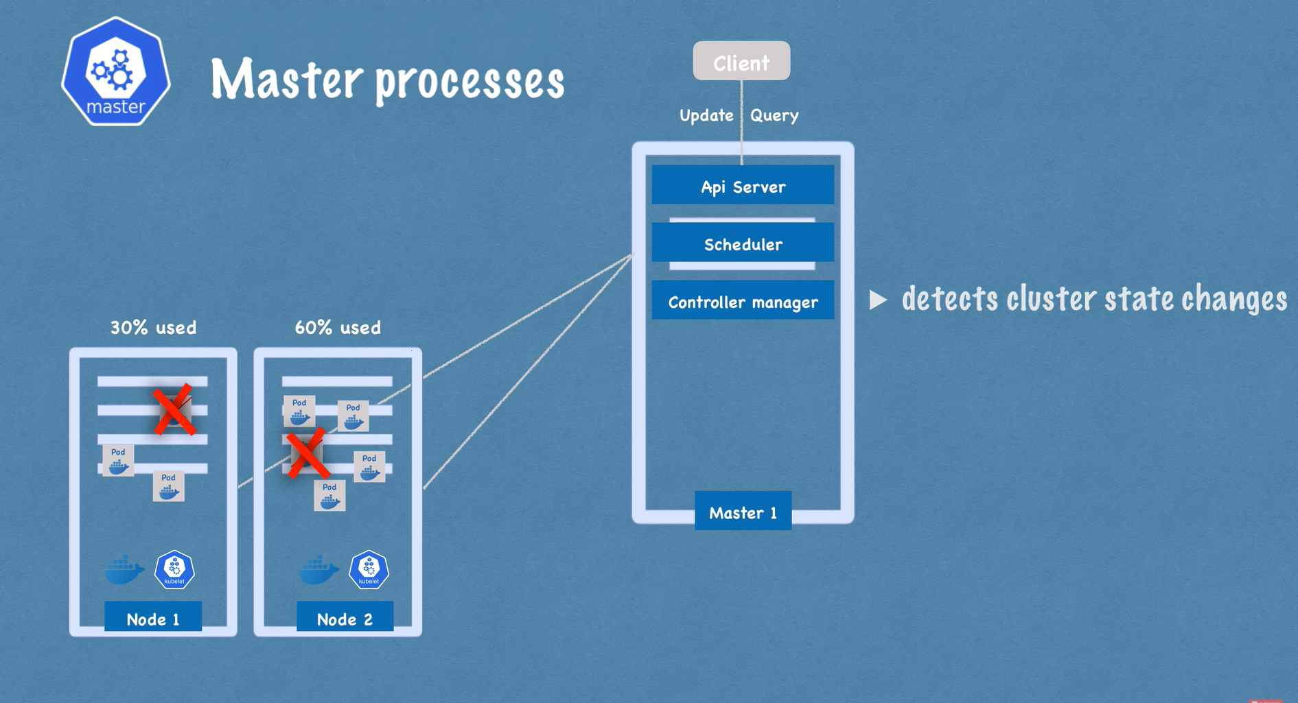 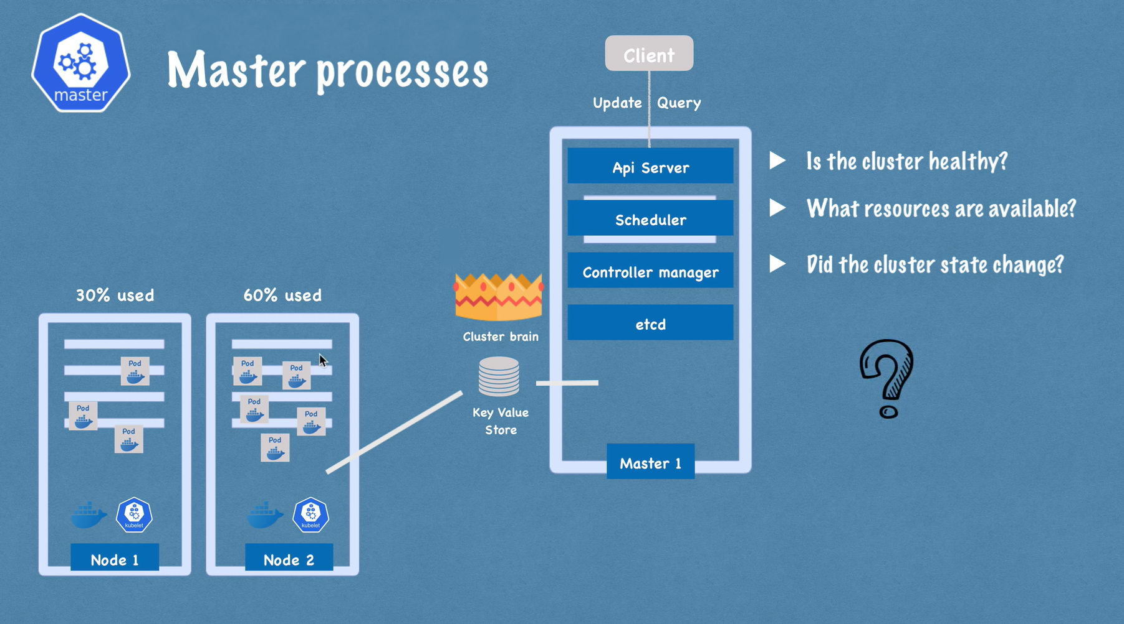 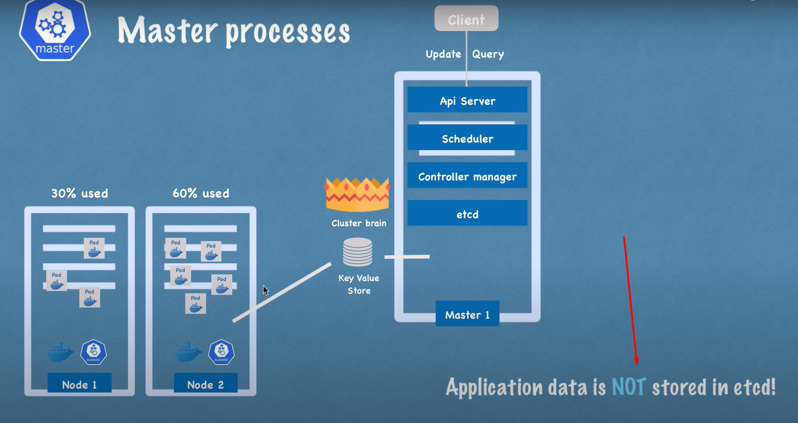

There are multiple Master Nodes

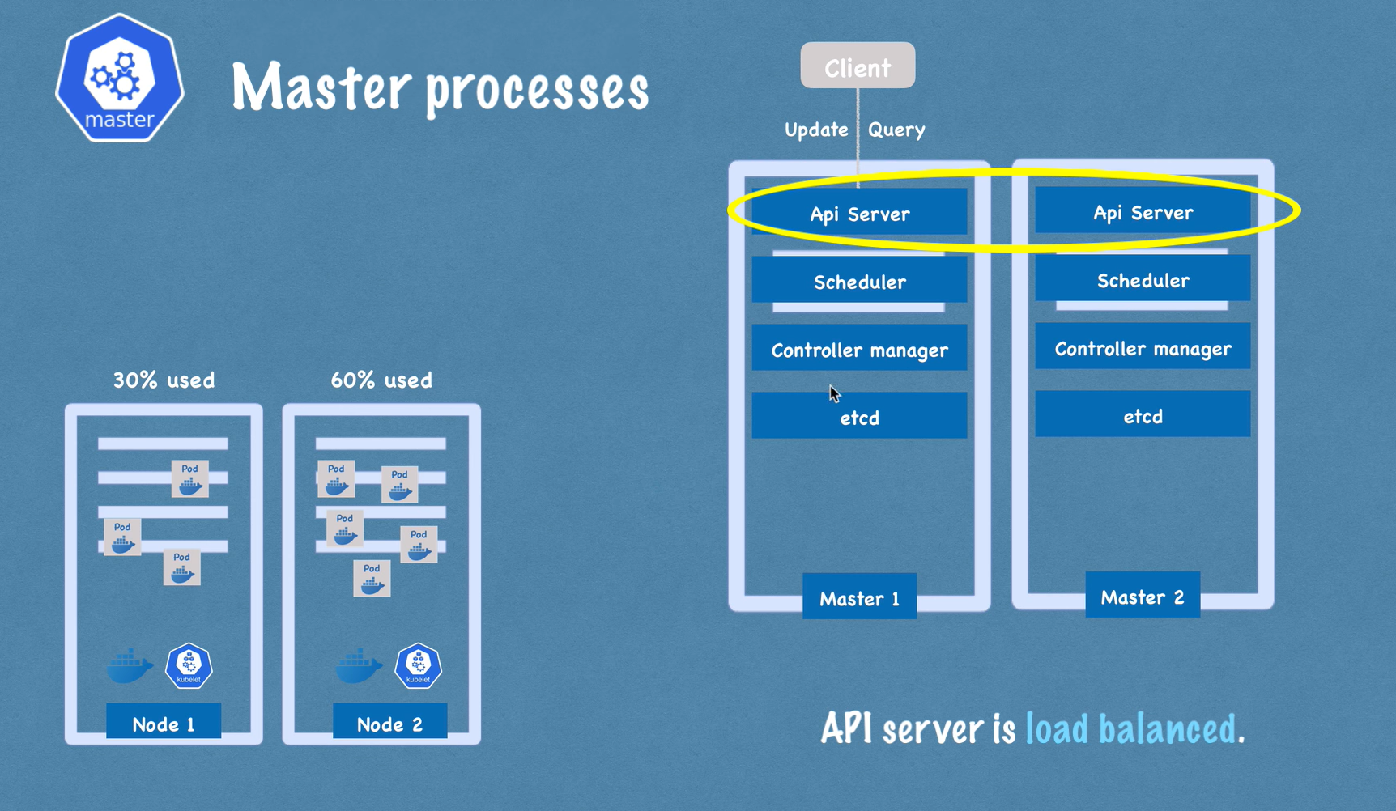 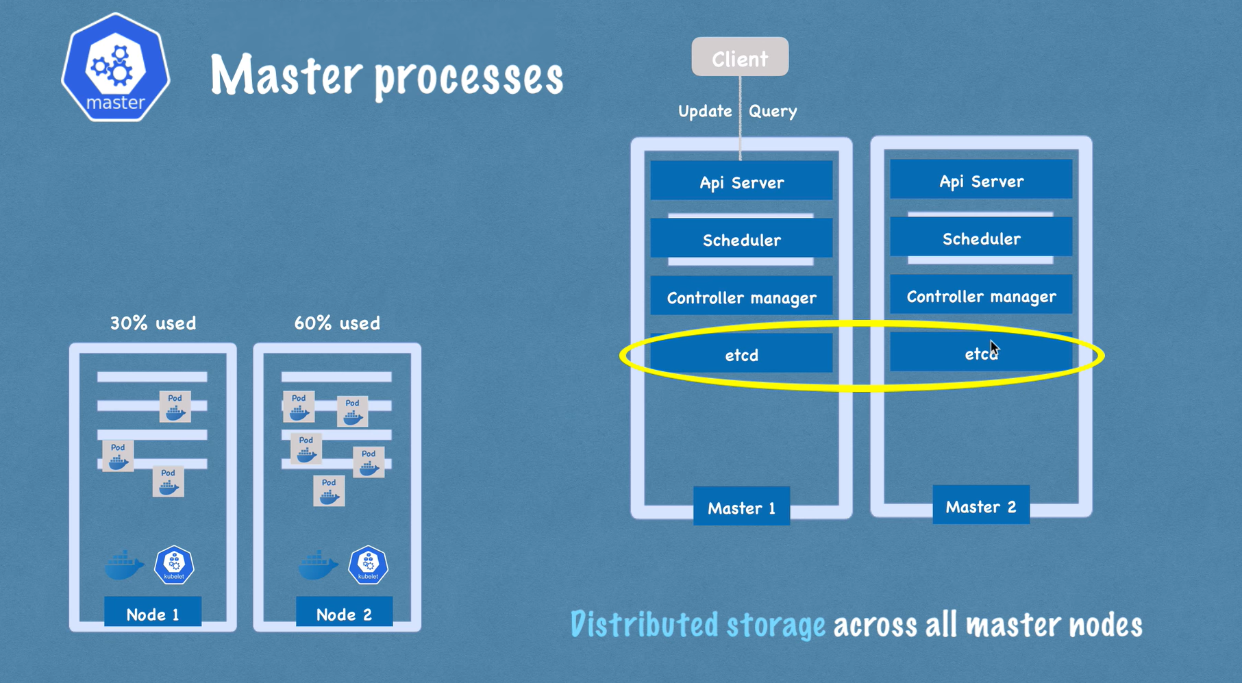

EXAMPLE OF CLUSTER SET-UP

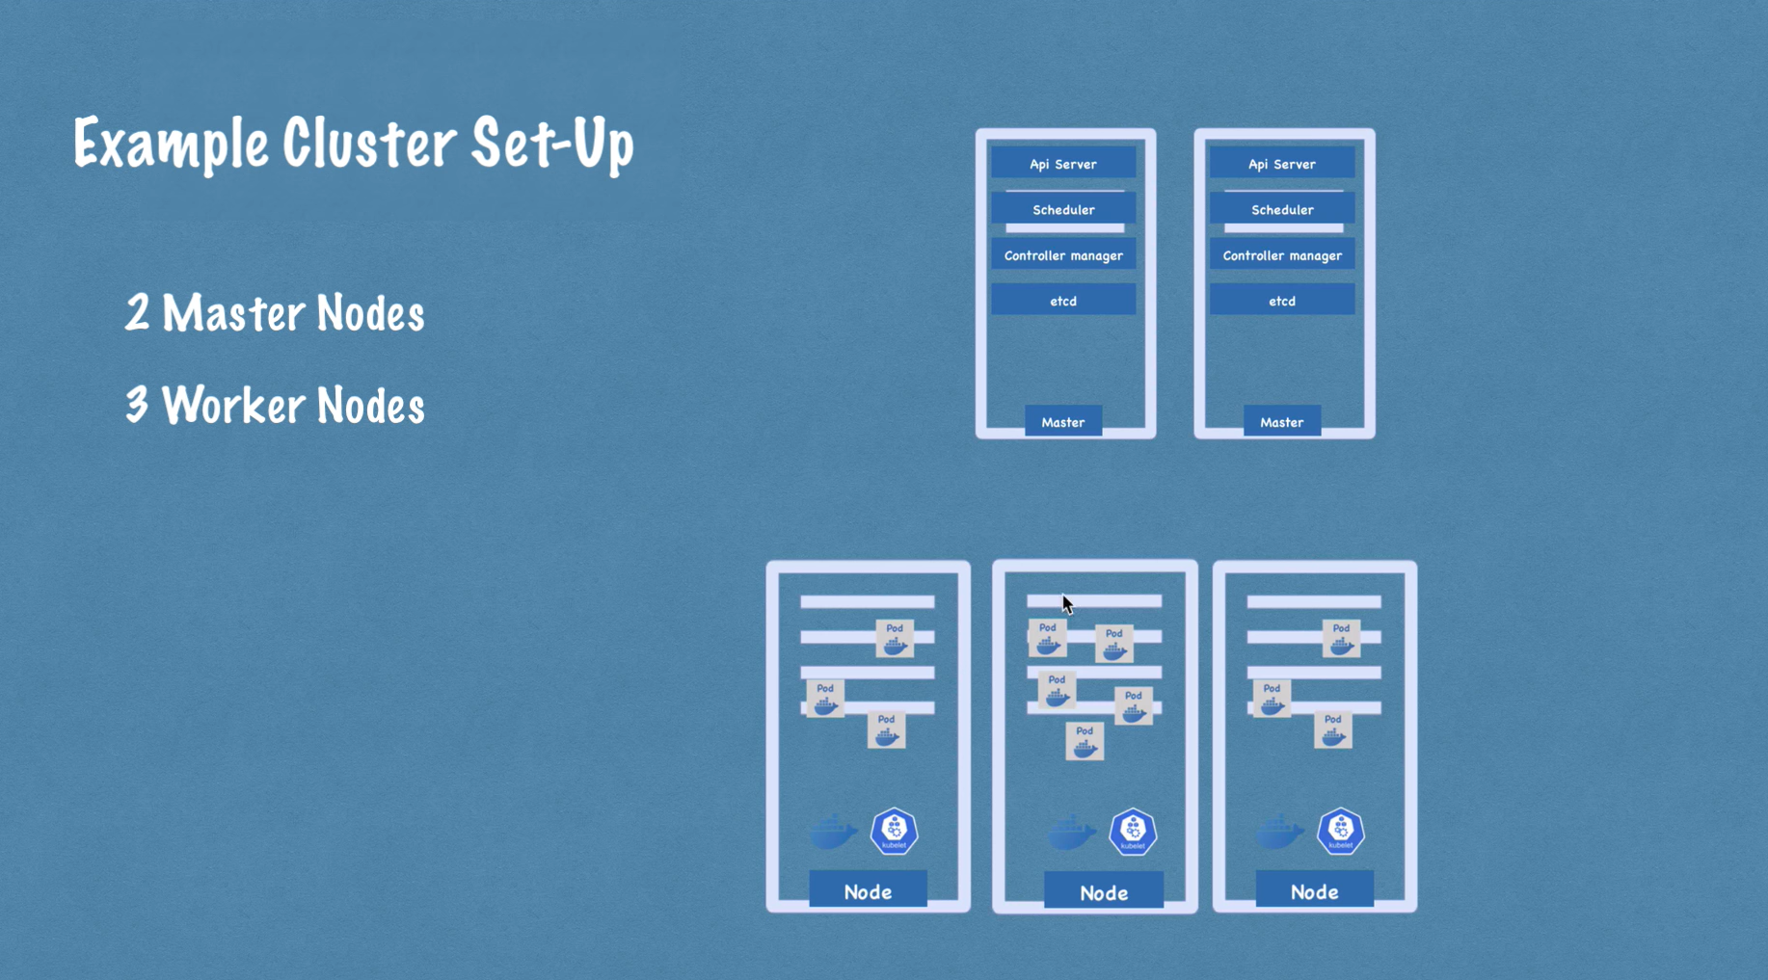

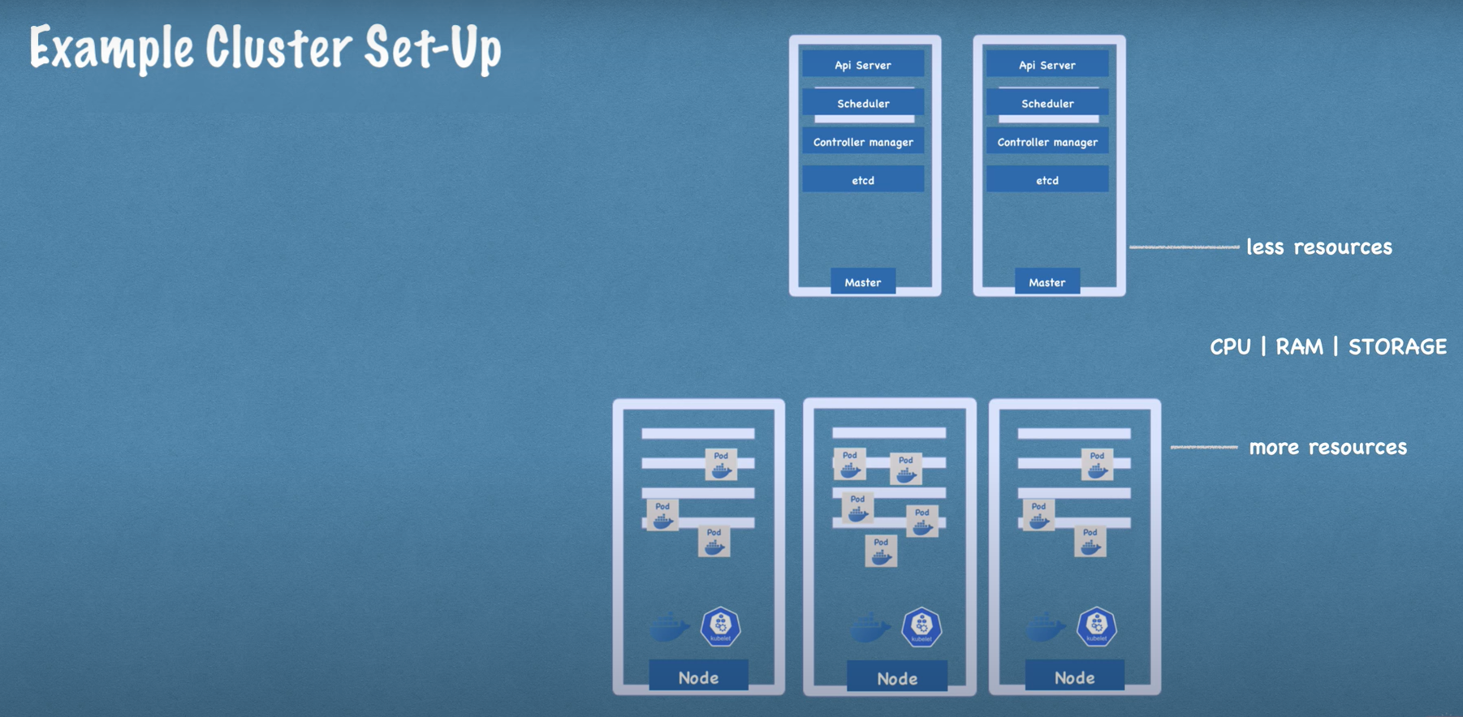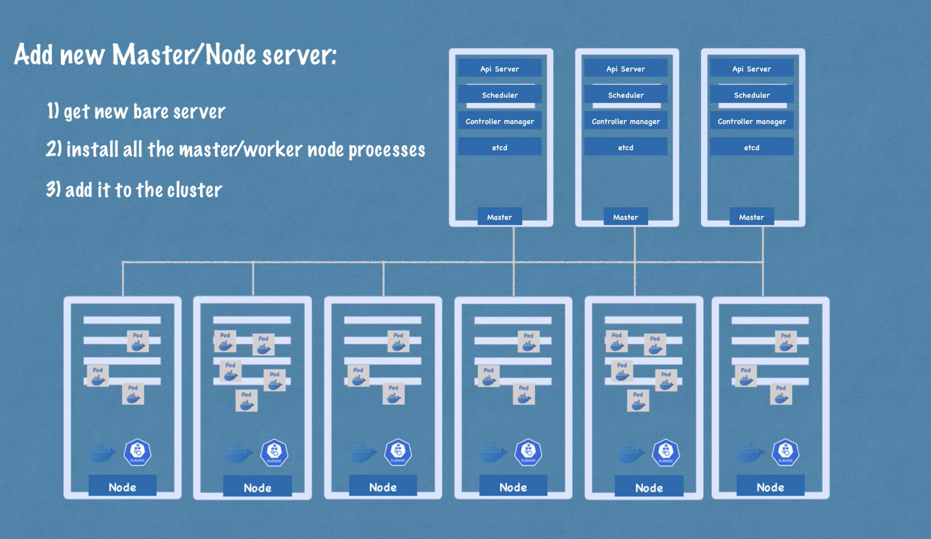

What is MINIKUBE?

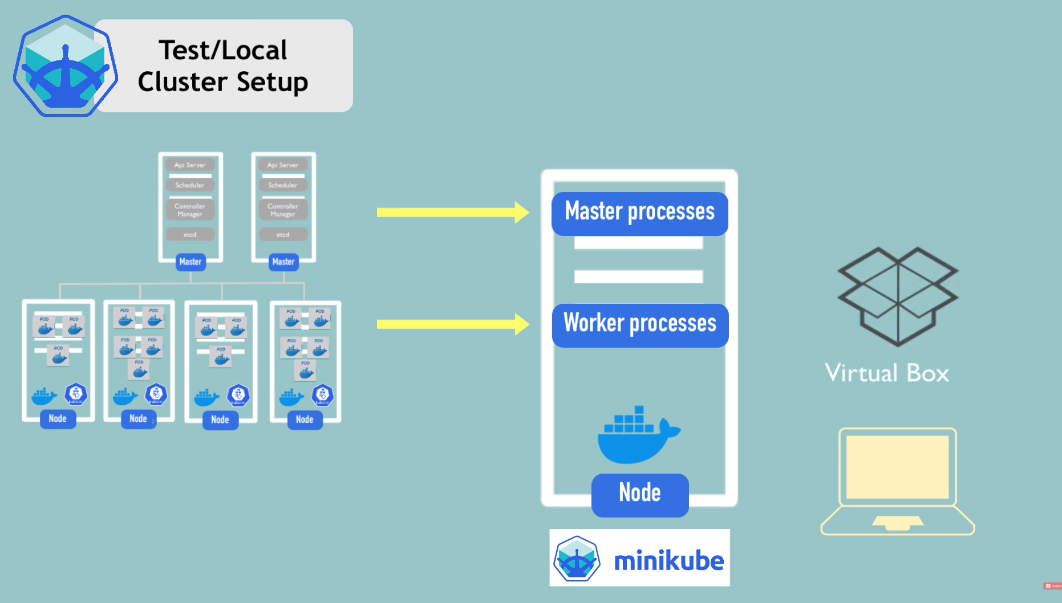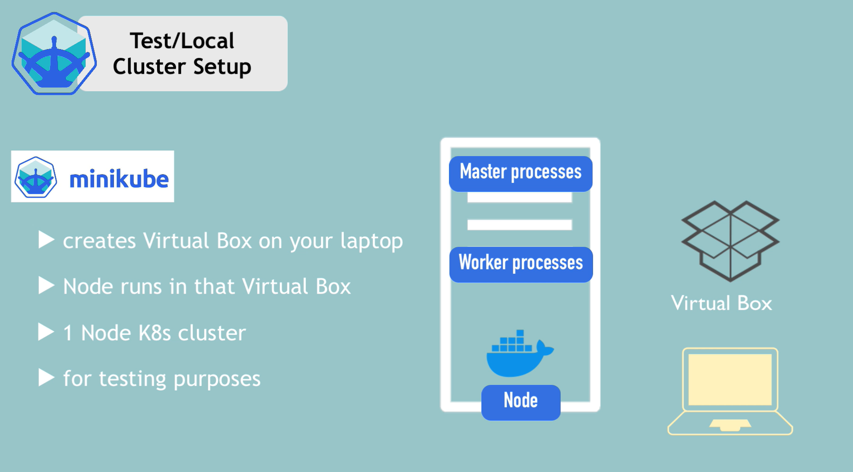

**KUBECTL is a command line tool for kubernetes cluster**

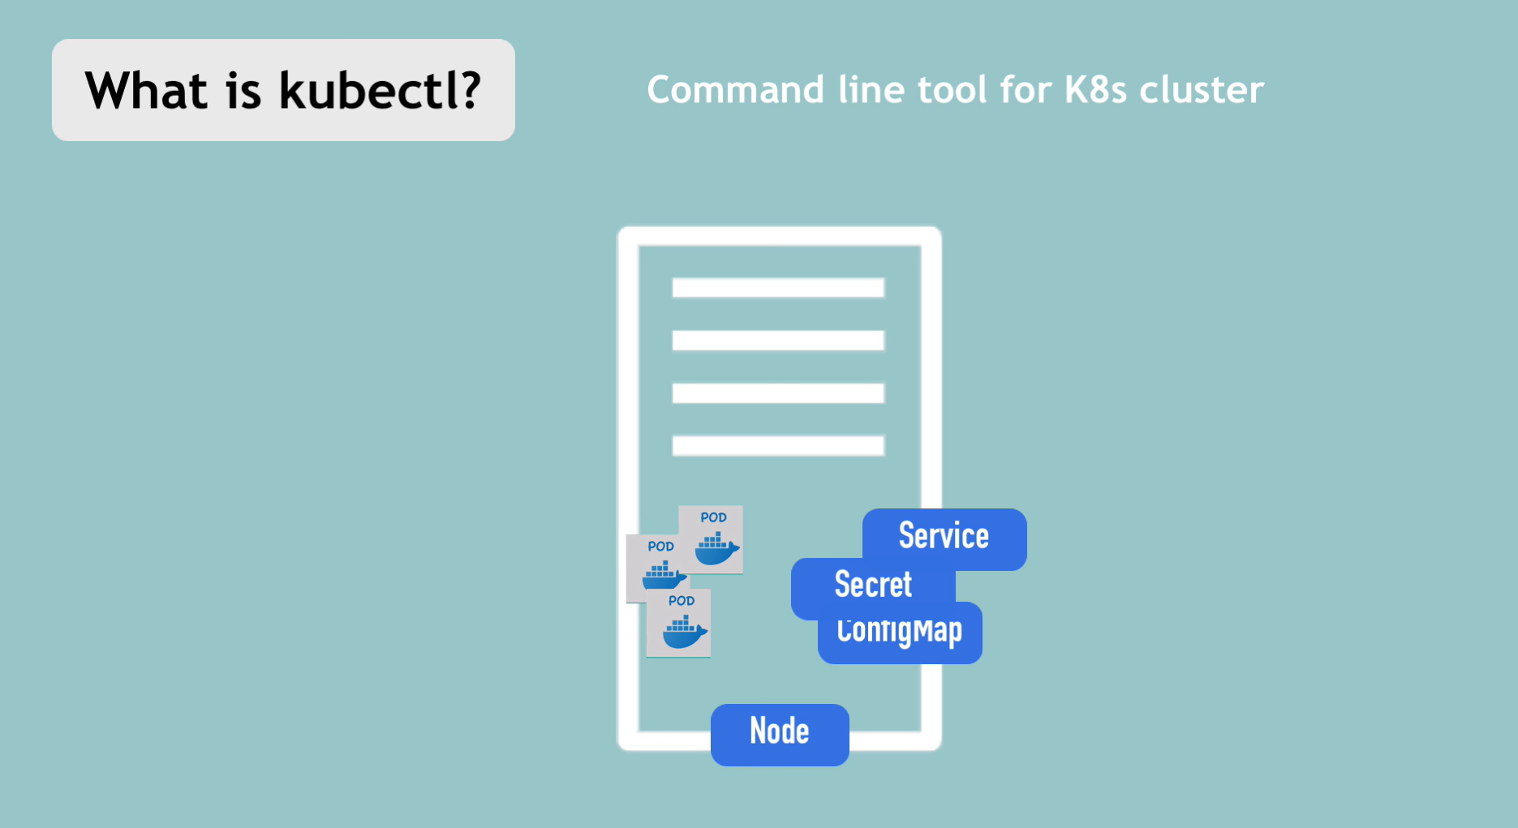

**KUBECTL interracts with MASTER PROCESS / API MASTER SERVER**

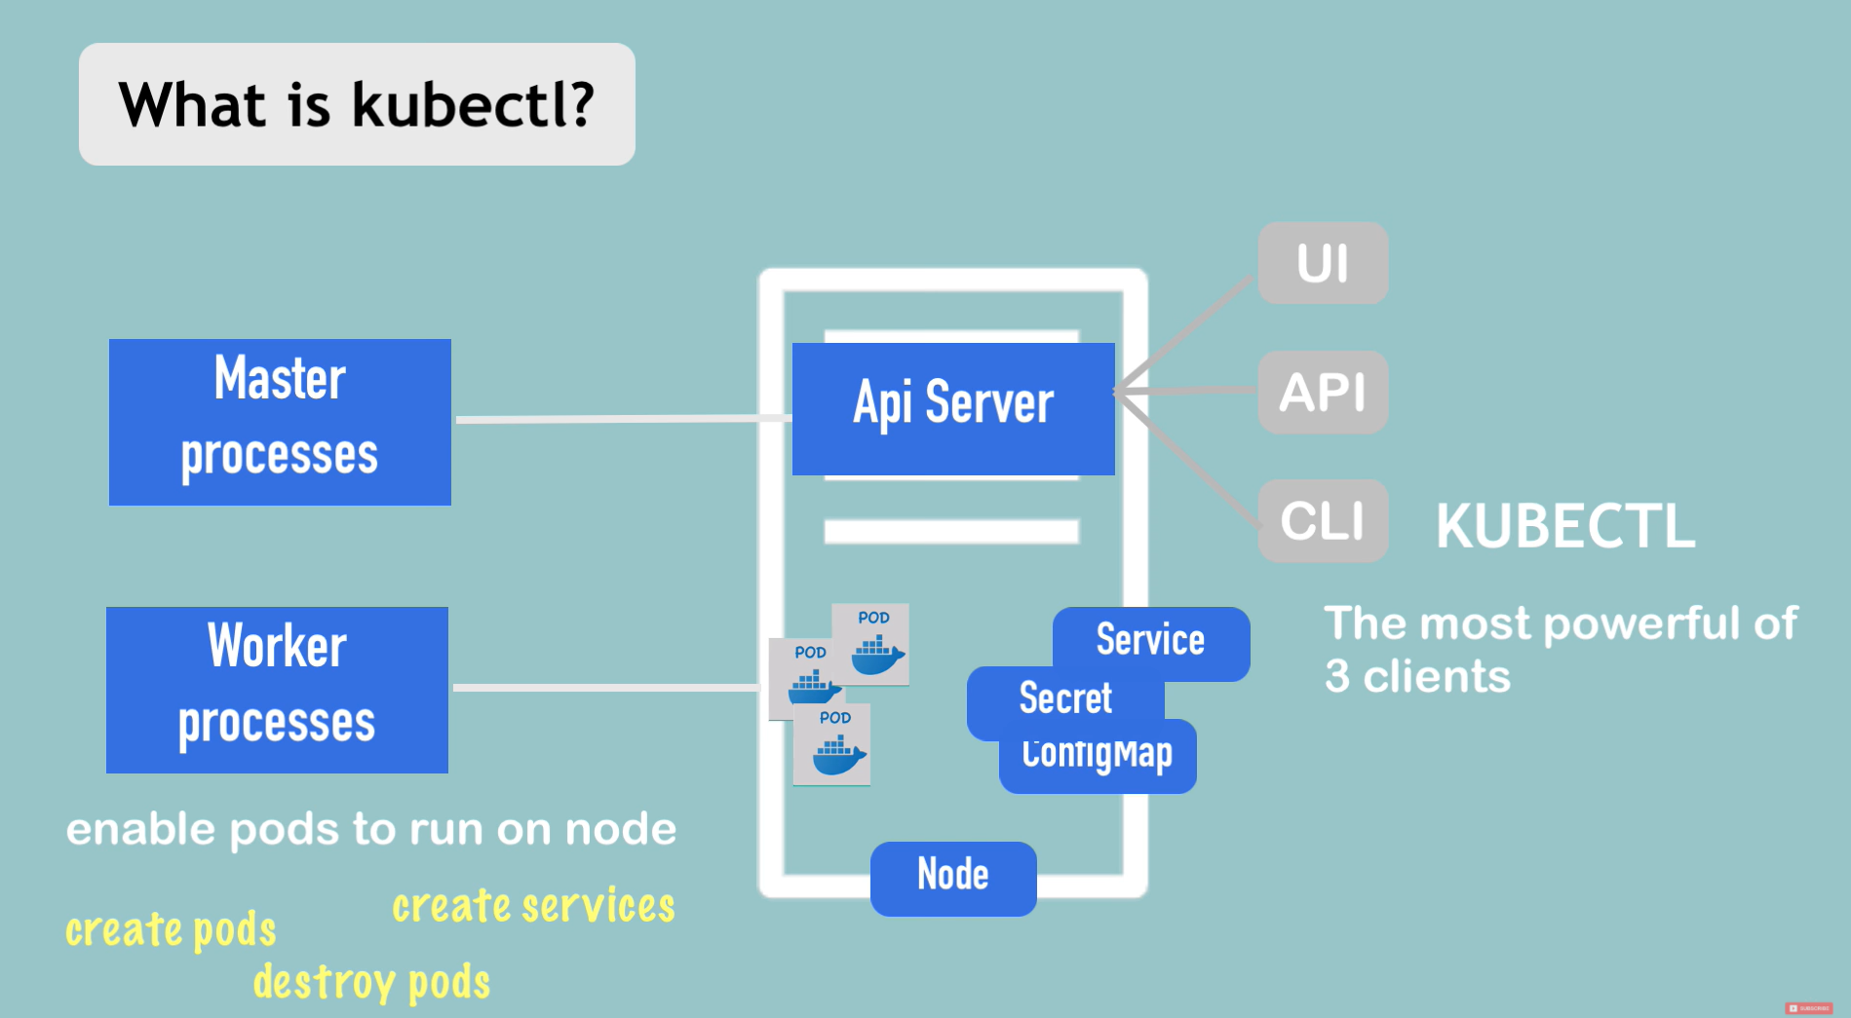

**KUBECTL interracts with any type of cluster**

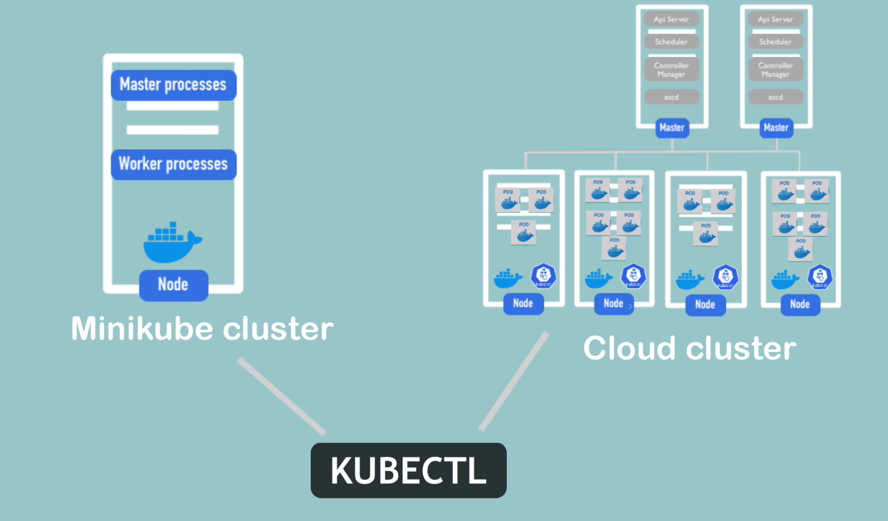

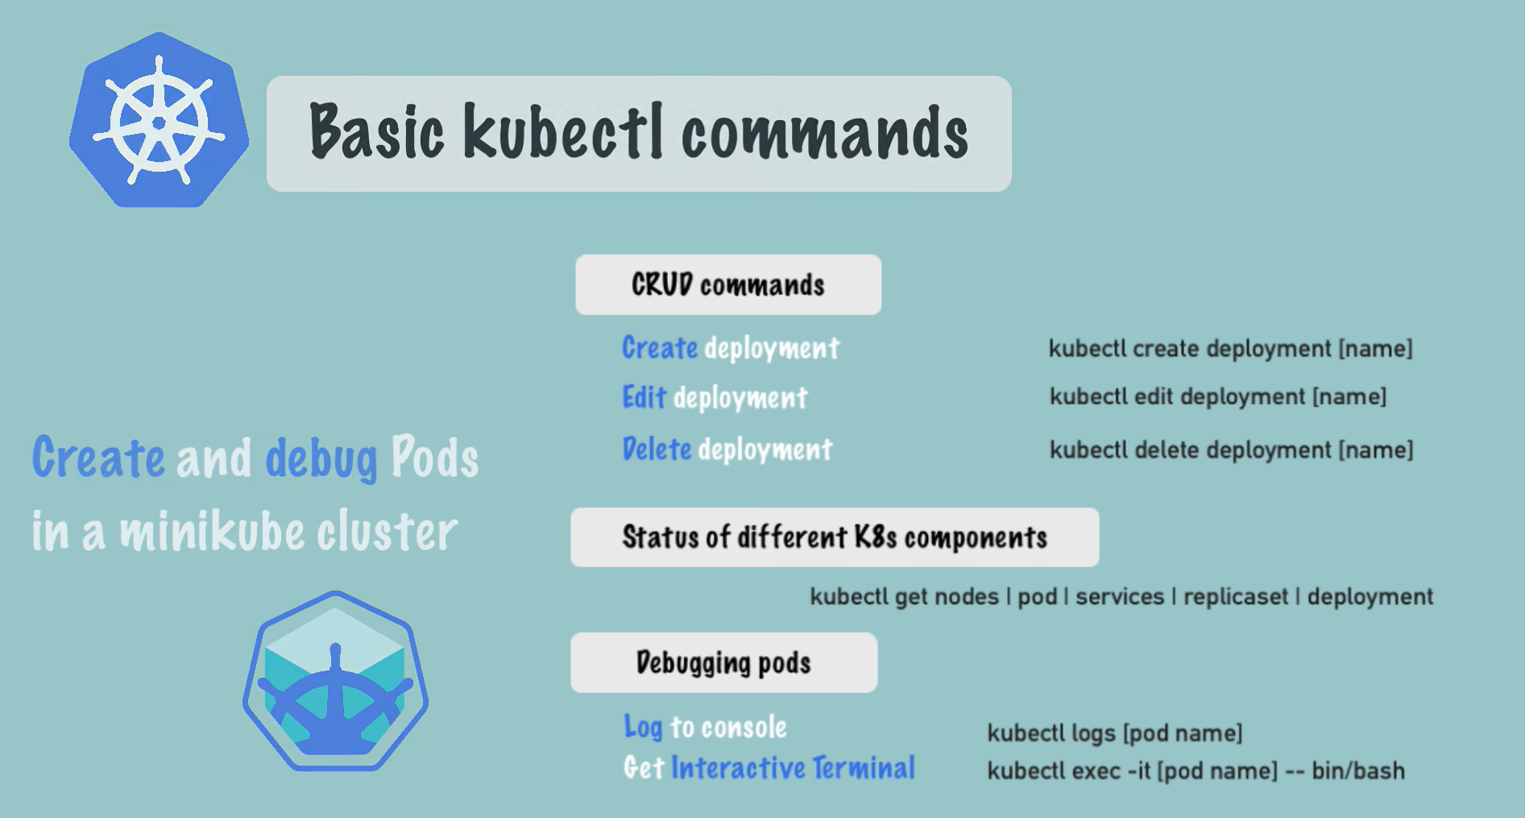

**Basic Kubectl commands:**

* 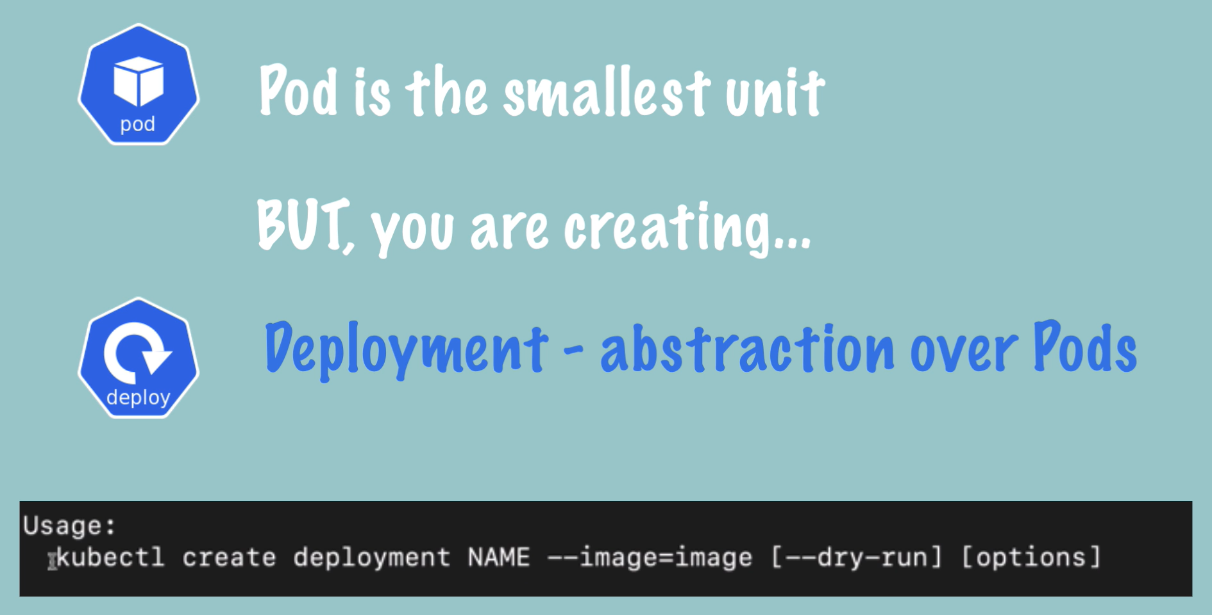
* kubectl create deployment nginx-depl --image=nginx = create deployment
* kubectl get pod = print all pods and their status
* kubectl get pod -o wide = print all pods and more details about them (including ip address)
* kubectl get deployment = print all deployments and their status
* kubectl get service = print all services and their status
* kubectl get replicaset = replicaset manages the replicas of a Pod
* 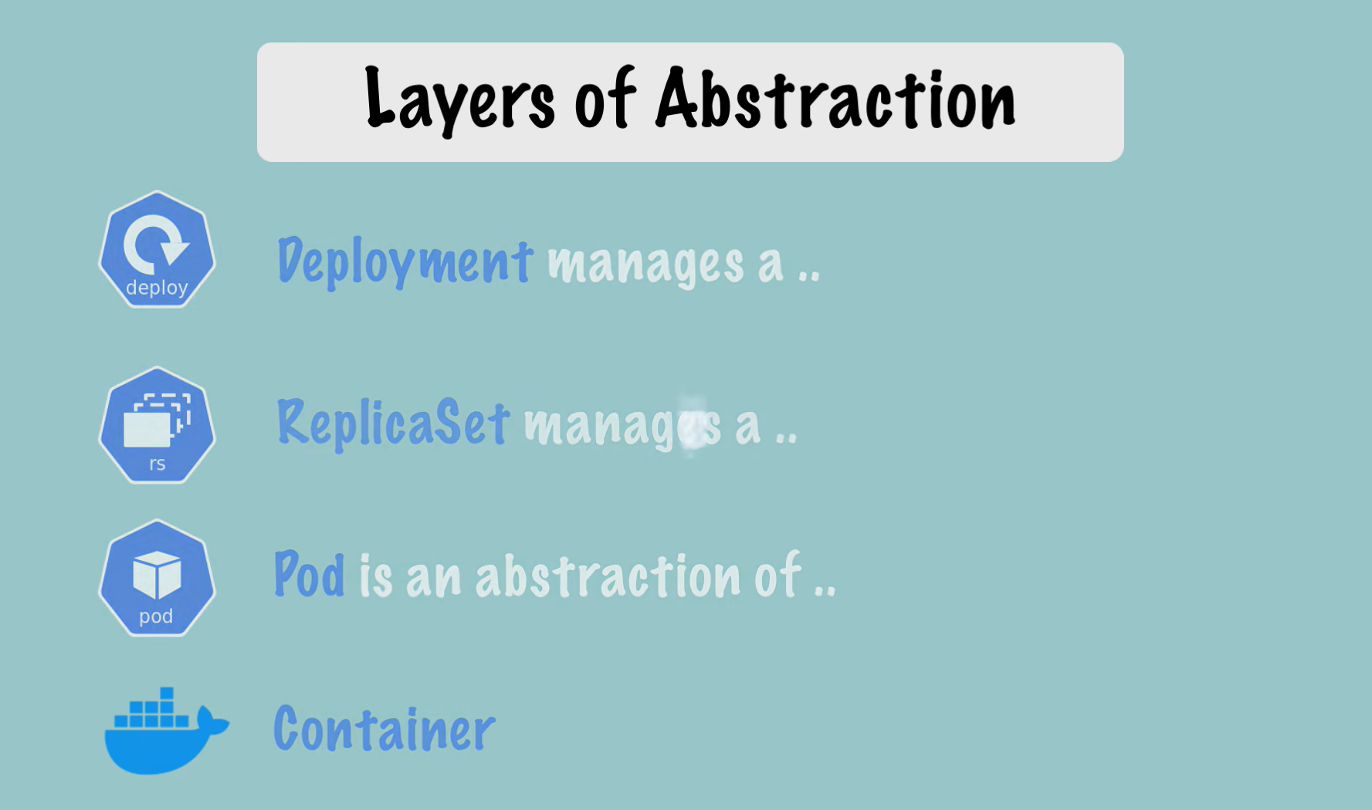
* kubectl edit deployment nginx-depl = allows editing of the Auto-genereated config file with default values
* kubectl logs [pod name] = print logs for
* kubectl describe pod [pod name] = print initial information about pod
* kubectl describe service [service name] = prinit informations about service
* kubectl exec -it [pod name] – bin/bash = lunch terminal of the containerized application
* kubectl delete deployment [deployment name] = delete the deployment
* kubectl apply -f app-config-deployment-file.yaml = create a deployment based on yaml configurations from file
* 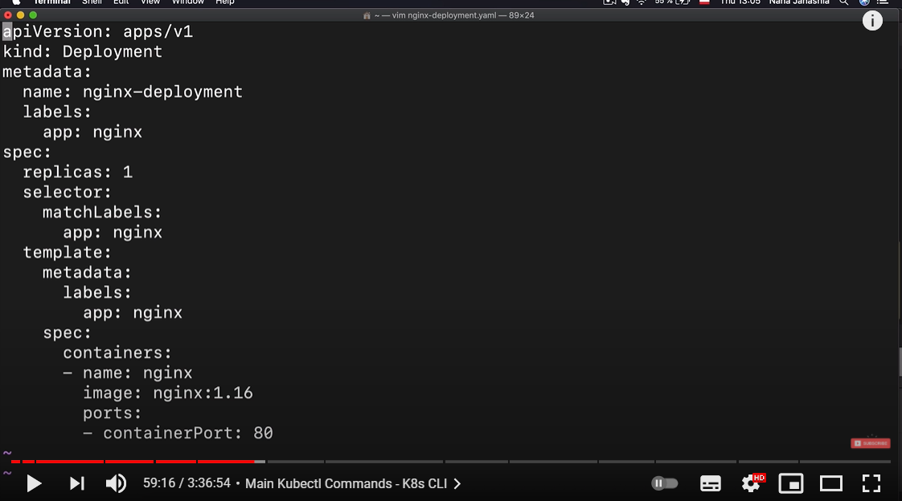
* 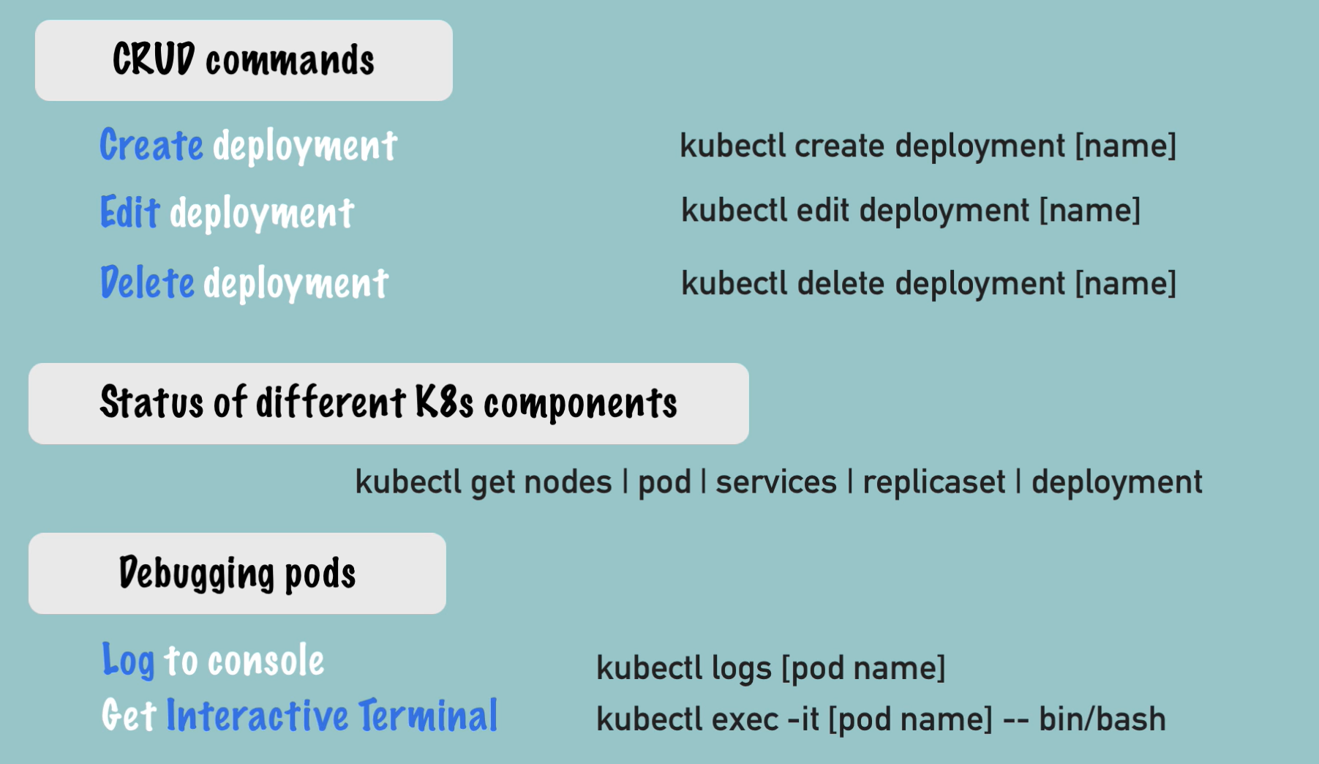
* 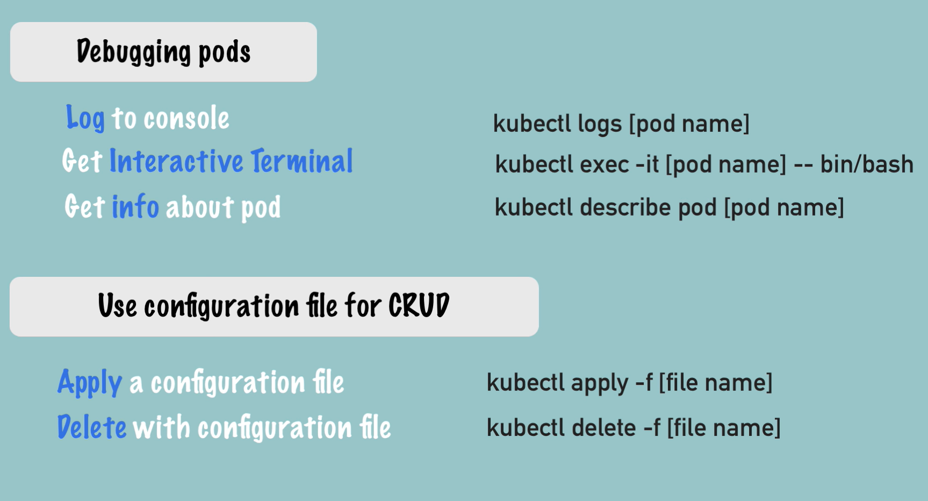

**YAML Configuration File in Kubernetes**

* 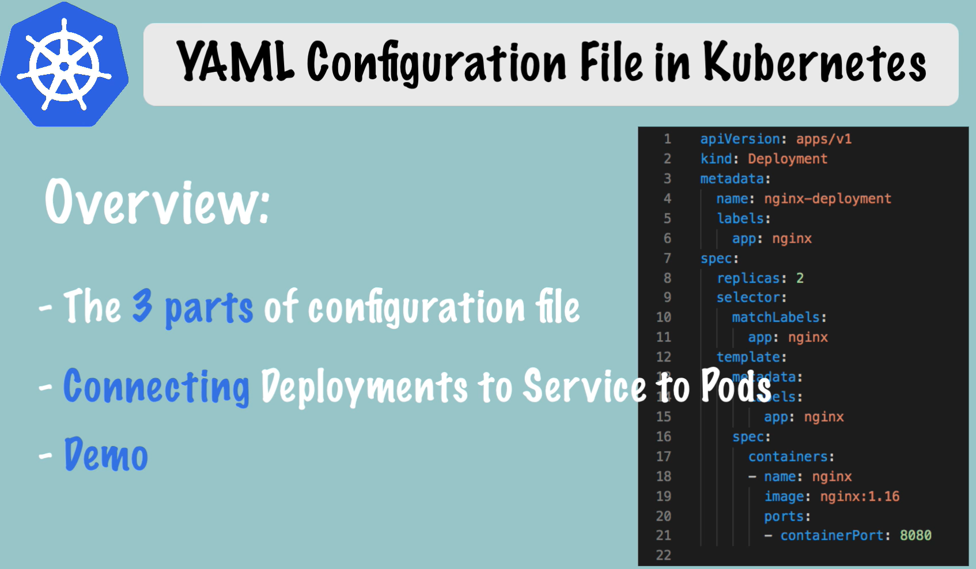
* The 3 parts of configuration file:
  + metadata:
    - 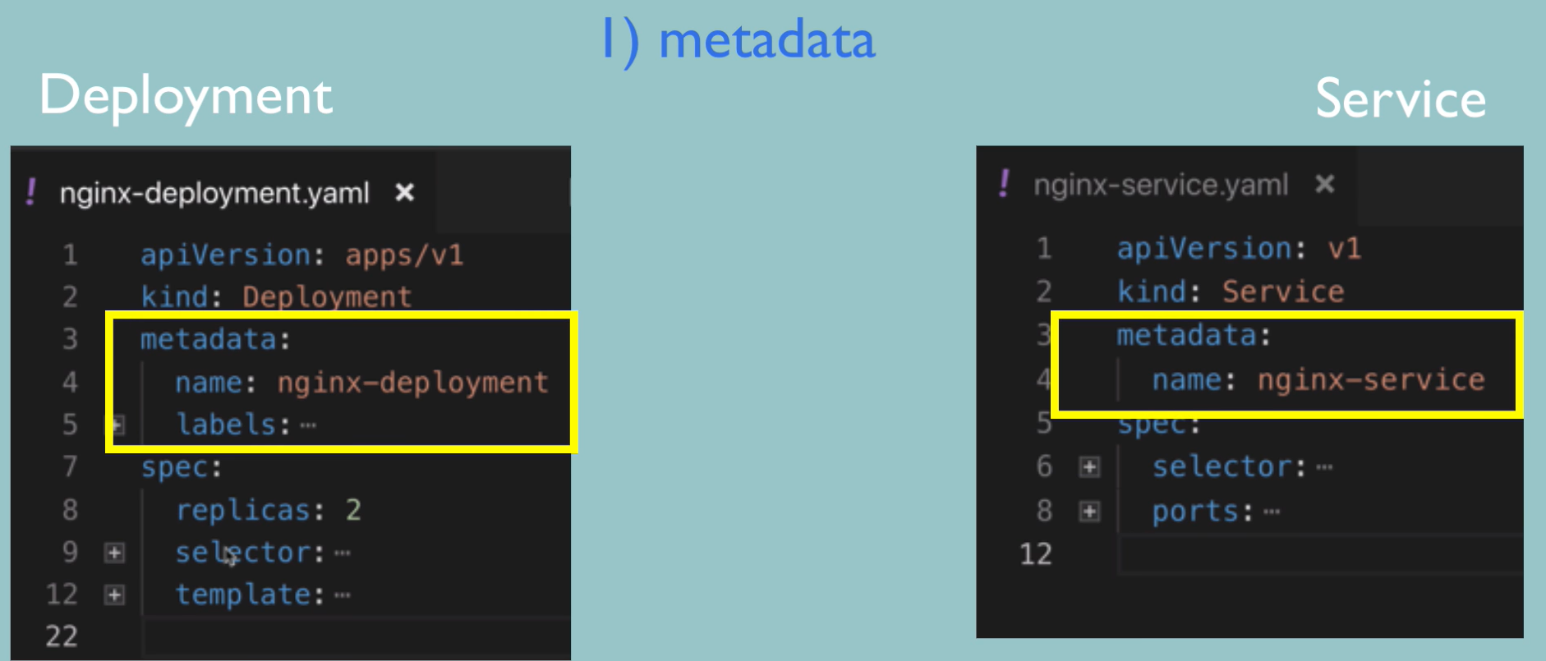
  + specs:
    - 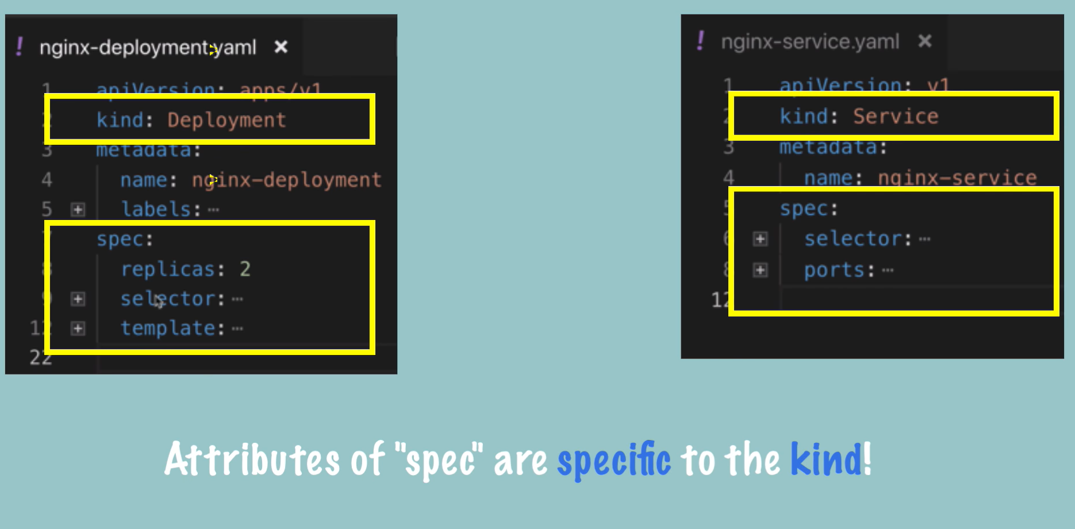
  + Actual Status & Desired Status:
    - 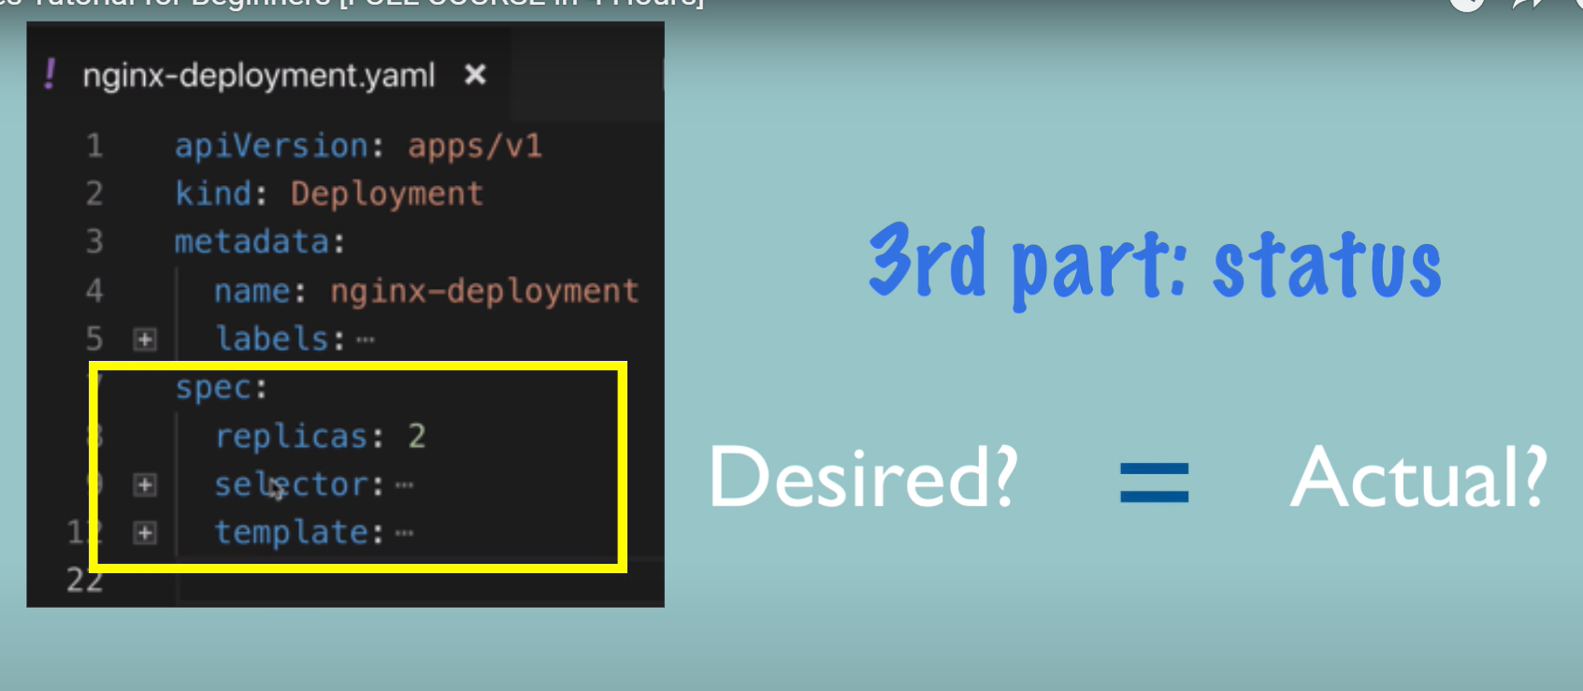
    - 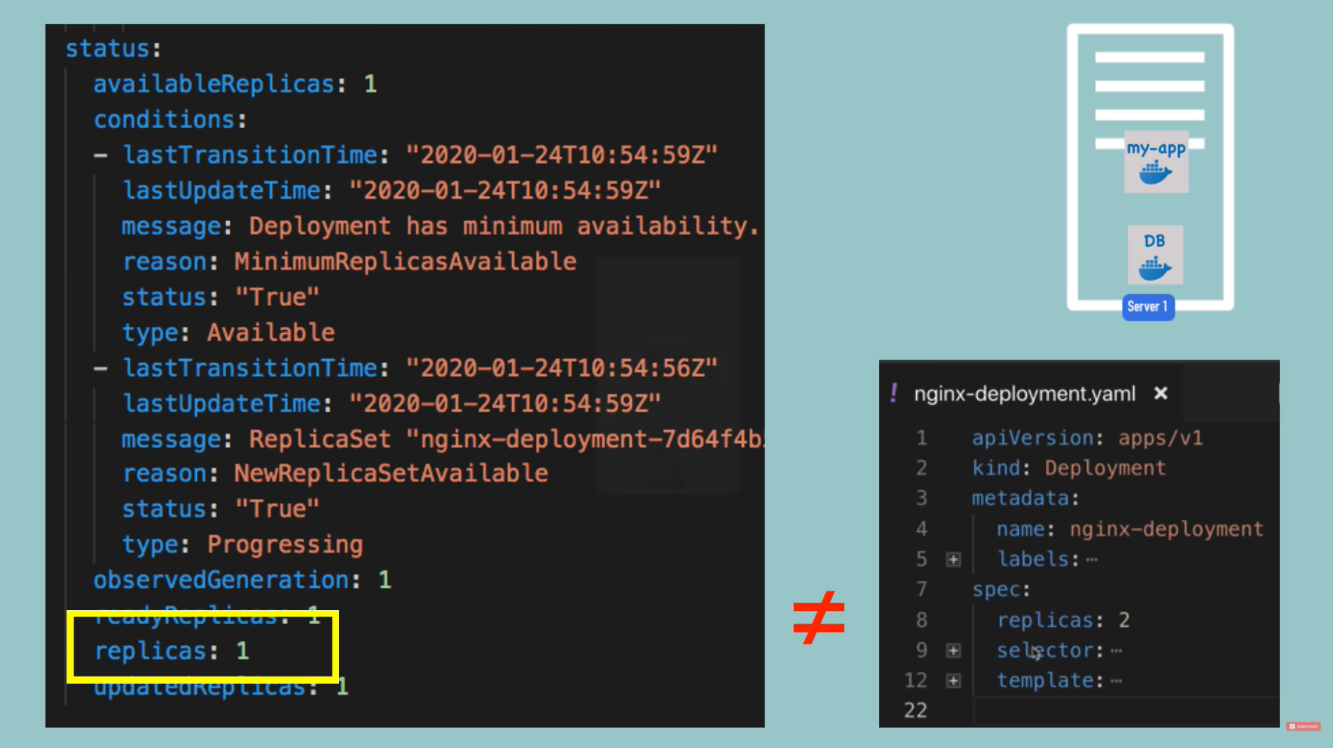
    - 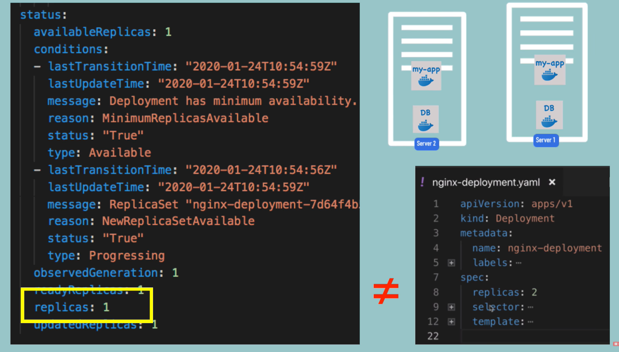
    - 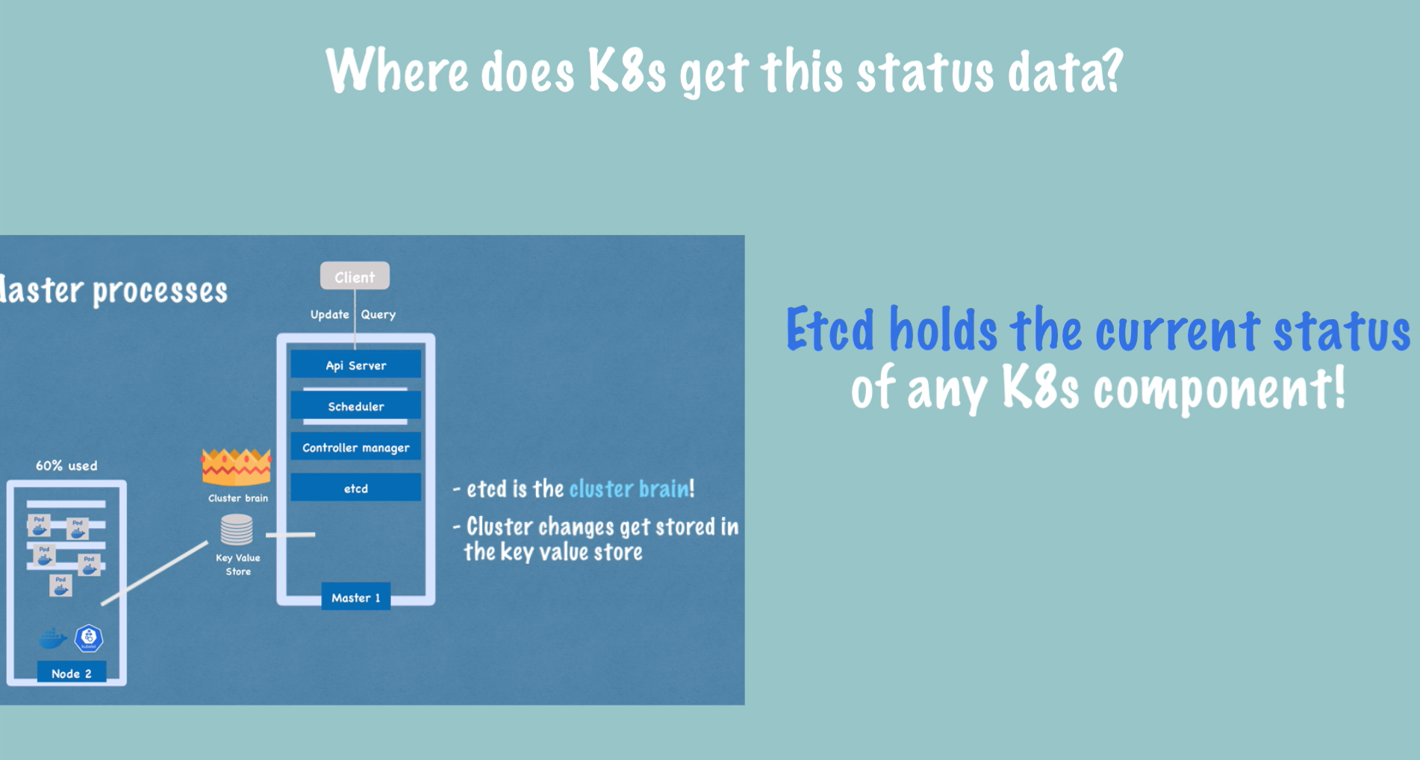
    - 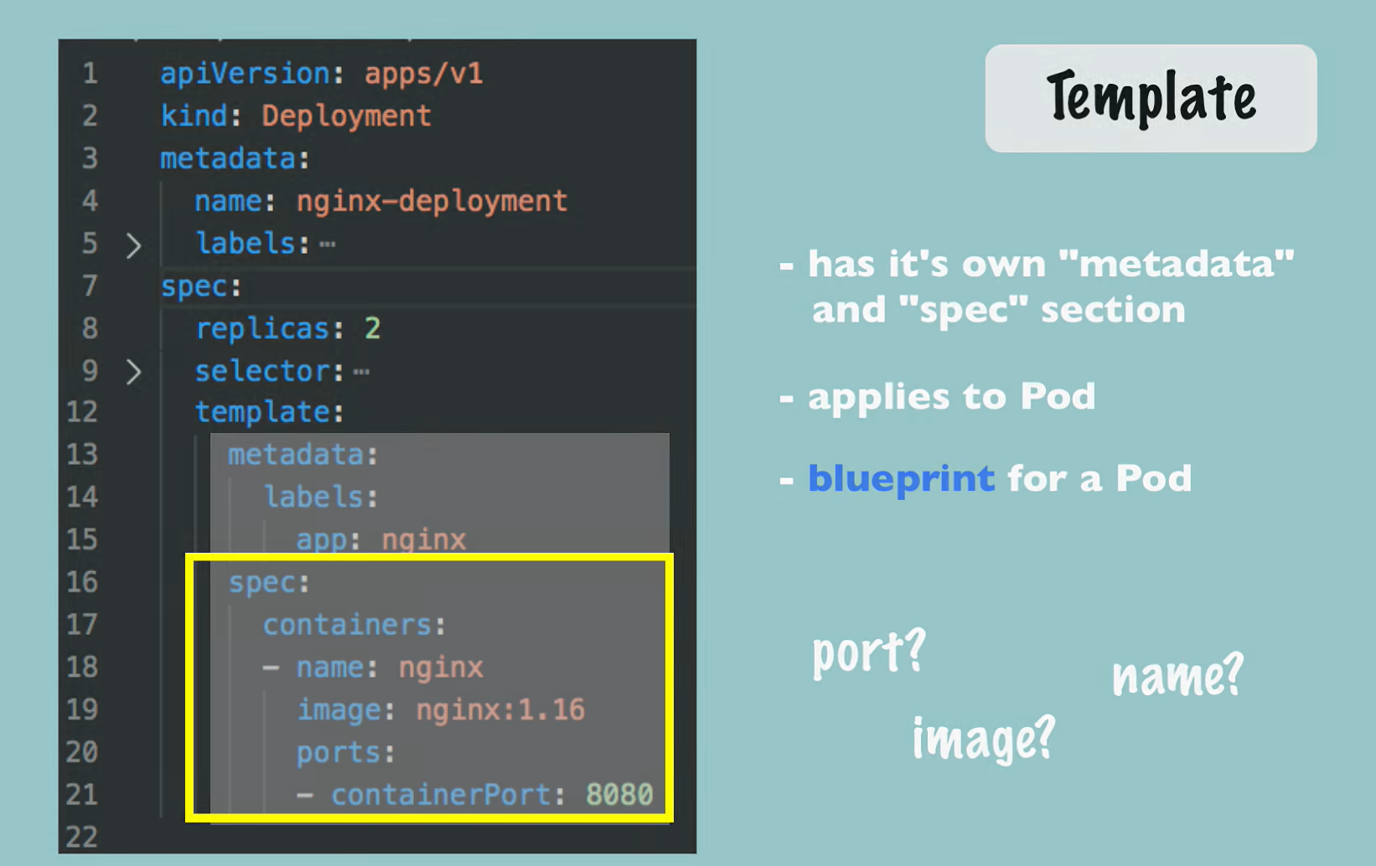
    - 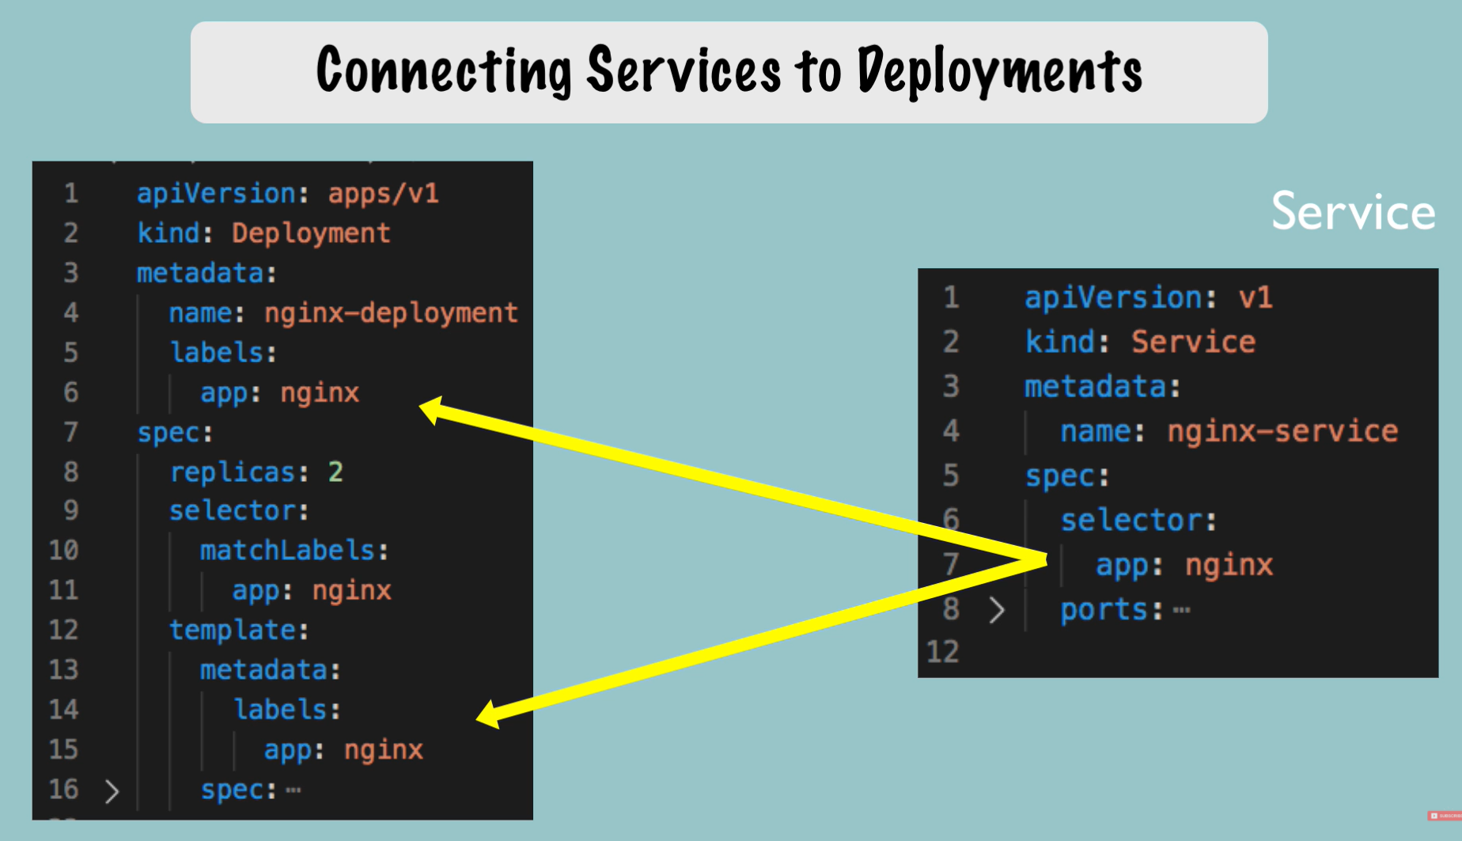
    - kubectl get deployment nginx-deployment -o yaml = get real time status and details about deployment (stored in etcd) in yaml format.
    - kubectl get deployment nginx-deployment -o yaml > nginx-deployment-result.yaml = save real time status and details about deployment (stored in etcd) in an yaml file.
      * the “**status: “** section is automaticaly updatedby **etcd**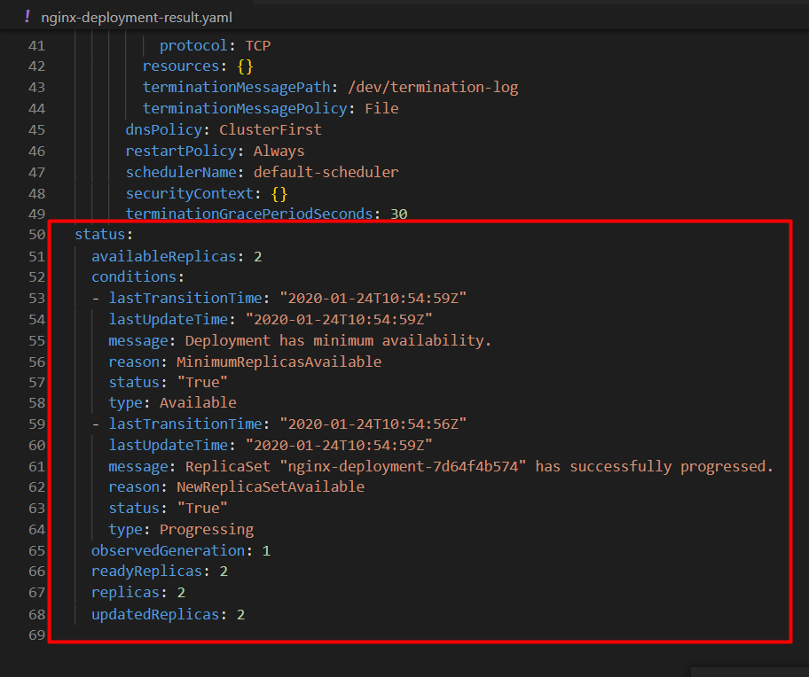
    - kubectl delete -f nginx-deployment.yaml = delete the deployment create using this yaml file
    - kubectl delete -f nginx-service.yaml = delete the service create using this yaml file

**Demo Project: MongoDB and MongoExpress**

